A dissertation submitted in partial fulfilment of the University of Greenwich’s BSc Computing

Student: Nguyen Doan duy thanh – gch17409 | Supervisor: PhD. Truong Cong doan

Final Year Project – COMP1682

Math online system

ABSTRACT

The research and development of technologies and system design to perfect the online math learning system using php language and some other techniques.

ACKNOWLEDGMENTS

In order to facilitate the research process, PhD Truong Cong Doan contributed a big part in changing my thinking in how I was able to improve my reporting skills as well as guide me on how to refine the code for my project.

Table of Contents

1 Literature review 8

1.1 Overview 8

1.2 E-learning methods and Traditional learning methods 8

1.2.1 E-learning methods 8

1.2.2 Traditional learning methods 9

1.2.3 Conclusion 11

1.3 E-Learning Market 11

1.4 Technologies 12

1.4.1 Font-end 12

*1.4.2* Back-end 15

1.4.3 Methodologies 21

1.4.4 Recommendation system 26

1.4.5 Conclusion 30

1.5 Other systems 31

1.5.1 Future learn 31

1.5.2 Edx 35

1.5.3 Conclusion 37

2 Requirements analysis 38

3 Design of math online system 40

3.1 Entity relationship diagram 40

3.2 Write Frames of High Level Requirements 41

4 Development of the system 45

4.1 Login form 45

4.2 Register form 47

4.3 Home page 48

4.4 All class 51

4.5 Class detail 52

4.6 Payment 53

4.7 Extend 54

4.8 Student profile 55

4.9 Home page – Teacher, staff 56

4.10 Add new class – teacher 57

4.11 All class – teacher 58

4.12 Class detail – teacher 58

4.13 Profile – teacher 59

4.14 Edit role – staff 60

5 Evaluation 61

5.1 Human Interaction 61

5.1.1 Visibility of system status 61

5.1.2 User control and freedom 62

5.1.3 Consistency and standards 62

5.1.4 Error prevention 62

5.1.5 Aesthetic and minimalist design 63

5.1.6 Help users recognize, diagnose, and recover from errors 65

5.2 Security 65

5.3 Testing 66

5.3.1 Test case 67

5.3.2 Evaluate 74

5.4 Product Review 74

Table of Figure

Figure 1: Scope of e-learning market report (Preeti Wadhwani, 2019) 12

Figure 2: Example of HTML 13

Figure 3: CSS example 14

Figure 4: Example code for php 16

Figure 5: Example of JavaScript 20

Figure 6: Principle of Waterfall Modeling (toolsqa, 2020) 22

Figure 7: Scrum framework (scrum, 2020) 25

Figure 8: Collaborative filtering process (Seif, 2019) 28

Figure 9: Recommender systems based content suggestions (Seif, 2019) 29

Figure 10: Futurelearn login (https://www.futurelearn.com/courses) 32

Figure 11: FutureLearn homepage (https://www.futurelearn.com/courses) 32

Figure 12: Subject menu(https://www.futurelearn.com/courses) 33

Figure 13: FutureLearn course detail(https://www.futurelearn.com/courses) 34

Figure 14: Futurelearn course detail(https://www.futurelearn.com/courses) 34

Figure 15: Futurelearn Payment(https://www.futurelearn.com/courses) 35

Figure 16: Edx homepage 36

Figure 17: Edx all course 36

Figure 18: edx class detail 37

Figure 19: user case diagram 39

Figure 20: Frames of login 41

Figure 21: Frames of home page 42

Figure 22: Frames of view class 43

Figure 23: Frames of class detail 44

Figure 24: Frames of payment 45

Figure 25: home page 46

Figure 26: login form 46

Figure 27: error alert 47

Figure 28: Register form 47

Figure 29: validation register 48

Figure 30: Home page 48

Figure 31: Home page 49

Figure 32: Home page 50

Figure 33: Home page 51

Figure 34: navbar 51

Figure 35: All class 51

Figure 36: Class detail 52

Figure 37: Class detail 52

Figure 38: payment 53

Figure 39: payment 53

Figure 40: Extend 54

Figure 41: student profile 55

Figure 42: edit profile 55

Figure 43: Home page – Teacher, staff 56

Figure 44: Add new class – teacher 57

Figure 45: All class – teacher 58

Figure 46: Class detail – teacher 59

Figure 47: file & video upload 59

Figure 48: Profile - teacher 60

Figure 49: Edit profile – teacher 60

Figure 50: Profile - staff 60

Figure 51: Edit role 61

Figure 52: Visibility of system status 61

Figure 53: User control and freedom 62

Figure 54: Consistency and standards 62

Figure 55: Error prevention 63

Figure 56: Aesthetic and minimalist design 64

Figure 57: Help users recognize, diagnose, and recover from errors 65

# Introduction

In today's era, technology has developed to digital 4.0 technology, people gradually get used to using the internet, and everything is processed through the network. So the current trend, online learning through the internet is completely becoming popular and useful. So I decided not to ignore this trend. I decided to deploy an online learning system through the internet, my system mainly users will learn and access to the video learning on the website, the benefit of online learning is that learners don't have to go anywhere. Since they only need to use their phone or computer on the website, they can conduct online learning anytime, anywhere without any problems.

# Literature review

## Overview

The goal of this project is to develop and build an online math-learning website. Therefore, in this section, we will discuss some issues directly related to this project. First, we will find out and compare two existing learning methods that are E-learning methods and traditional learning methods. We can then analyze the potential of the education market when implementing an online learning system at this time. Thereby people can realize the importance of an online learning website as well as the benefits it brings in this era of technology 4.0. Finally, since this is a system built on a website platform, we have a multitude of choices about the technology used to implement this project so we will analyze and find out which direction we like merge for this project.

## E-learning methods and Traditional learning methods

### E-learning methods

E-Learning is the use of Web and Internet technologies in learning. E-Learning is a term used to describe learning, training based on information technology and communication. E-Learning means that learning or training is prepared transmitted or managed using many different information technology and communication tools and done locally or globally. Learning is transmitted or supported via electronic technology. The transmission is through a variety of technologies such as the Internet, TV, intelligent teaching systems, and computer-based training.

**Advantages**

* E-learning transforms the learning style as well as the student's role. Learners play a central and proactive role in the training process, can learn anytime, anywhere, as long as there are facilities to support learning.
* Learners can study according to their individual schedule, at a rate depending on their ability and can choose the learning content, so it will greatly expand the audience. Although it cannot completely replace the traditional training method, E-learning allows solving a difficult problem in the world education sector: the training needs of workers and students increase. Overburdened compared to the training facilities' capabilities.
* E-learning will appeal to a lot of learners, even those who have never been attracted to the old style of education before and it is very suitable for working people but still wants to improve their skills degree.
* Distance training programs in the world today have reached a rich level of interfaces, using a lot of multimedia effects such as sound, images, three-dimensional animations, animation, ... high interaction between user and program, direct conversation over the network. This brings students the excitement and passion in the process of acquiring knowledge as well as effective in learning.
* E-learning allows students to fully master their own learning process, from the time and amount of knowledge to learn as well as the order in which they are learned, especially for online lookup of relevant knowledge. to the lesson instantly, quickly review the lessons learned, freely exchange new learners or teachers during the learning process, things that the traditional way of learning is impossible or demanding asking cost is too high.

**Disadvantage**

* Although some courses are supported with technology platforms that allow teachers and learners to interact, online learning has not created much motivation for learners.
* Online instructors will face certain difficulties such as preparing lessons in a different way, requiring not only specialized knowledge but also knowledge and skills to use technology.

### Traditional learning methods

**Advantages**

* Traditional classrooms promote and stimulate a spirit of cooperation in learning, which enhances learners' self-awareness, makes the learning process easier, and learns harder in class and after when out of the classroom.
* Traditional classrooms enhance the skills of deep thinking, critical thinking because in class learners can participate (or be forced to participate) in discussions and discussions. At that time, learners are forced to mobilize critical thinking and deep thinking skills to form ideas and reason to argue and defend their views.
* Traditional classrooms promote social communication skills by having direct student interaction as well as between learners and teachers, creating relationships in the classroom. This is an important content of education, helping to develop social communication capacity for learners, especially young children.
* Traditional classrooms build students with disciplinary skills such as arriving in class on time, doing adequate homework before class, being prepared to answer any questions the teacher has, and ready to go. willing to participate in discussions ... In short, learners will have to know how to organize their time, obey the discipline in the classroom ...
* The traditional classroom stimulates the learners' attention and concentration. The presence of the teacher itself has been a driving force for learners to fully interact and participate in class activities.
* Traditional classrooms allow teachers to adjust teaching methods according to learners' reactions or change teaching content according to problems raised by learners. In terms of learners, the teacher can quickly explain questions or questions raised about a certain content of the lecture before entering the next learning topic.
* The traditional classroom develops personality and career skills important to learners. In the traditional classroom, problem solving skills, the ability to confidently present to friends and teachers, develop a spirit of teamwork ... are rarely found in online classes.

**Disadvantages**

* The study time is arranged, specific and limited schedule. Because the characteristic of traditional learning is to organize a class in a room and have a classroom teacher to guide the students (participants) on the pre-compiled knowledge according to the lesson plan, the study time will be permanent. Class time is traditionally scheduled and students are required to attend on time to not miss the amount of knowledge of that session.
* Tuition fees are often expensive. A traditional classroom usually only has a few dozen students who have the highest level of only 120 students to ensure the quality of teaching. In addition, traditional classrooms need to invest in space and equipment (tables, tables, chairs, electric lights, fans, air conditioners, projectors ...) but only serve a few students in the same area time. Therefore, tuition fees in traditional classes will usually be high enough to have enough money to organize the teaching and maintenance.

### Conclusion

Whether it is traditional methodology or online learning, there are different advantages and disadvantages. Therefore, through the aforementioned advantages and disadvantages, we still have to affirm that traditional learning methods are necessary and cannot be eliminated. However, in the current technology era, everyone owns at least one device with access to the internet system, besides, the trend of online learning becomes more and more popular. Therefore, the development of e-learning is undeniable and no, e-learning still has a great potential for growth in the near future.

## E-Learning Market

According to Preeti Wadhwani (2019), the size of the E-Learning market has surpassed the $ 200 billion milestone in 2019 and is expected to grow at a CAGR of over 8% in the future from 2020 to 2026. Currently, E-learning is developing unevenly in all regions of the world. Growing strongest in North America and Europe, while Asia and Southeast Asia are two regions, although the application of this technology has many shortcomings, but the prospects are bright.

The virtual classroom technology in the e-learning market is expected to grow at a CAGR of 11% over the forecast period. A virtual classroom is a digital environment that allows face-to-face interaction between tutors and learners. Videoconferencing and online whiteboards for real-time collaboration are the most commonly used tools in digital teaching spaces. Synchronous and collaborative virtual classes allow students to participate actively, creating an environment similar to a physical classroom.

The technique is gaining traction with more and more corporate fields and academics deploying it for advanced training sessions. Multilateral organizations and agencies around the world, such as WHO and G20, are also implementing e-learning methods to teach healthcare professionals. The International Air Transport Association (IATA) has developed a one-day electronic course on Contractual Obligations in COVID-19 to provide knowledge of contractual terms and how to interpret them. For aviation professionals in the current world economic crisis.

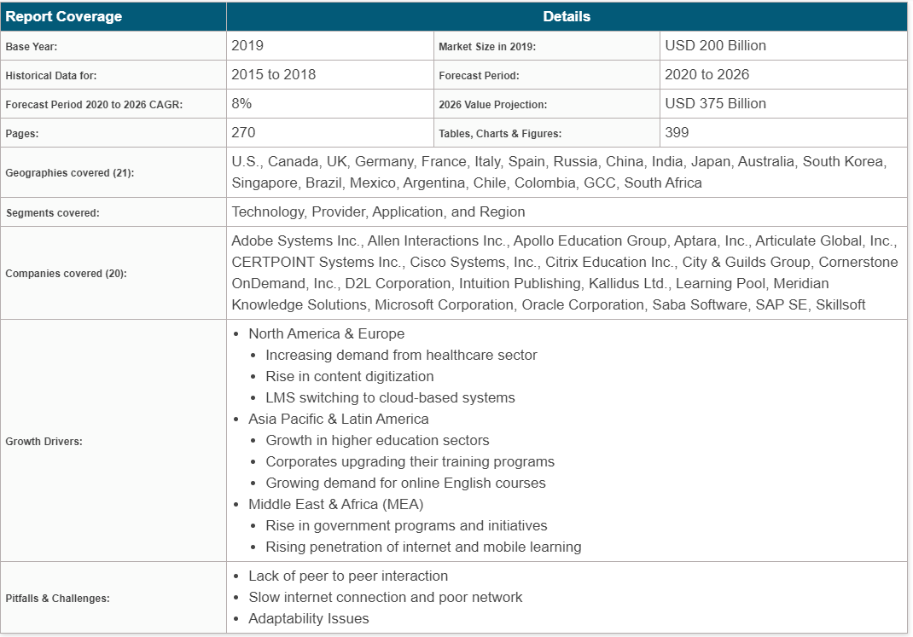

Figure 1: Scope of e-learning market report (Preeti Wadhwani, 2019)

## Technologies

### Font-end

#### HTML

HTML stands for HyperText Markup Language1) (translated as HyperText Markup Language) is used to create a web page, on a website can contain many pages and each page is defined as a HTML data (sometimes I will write it as an HTML file). The father of HTML is Tim Berners-Lee, also the creator of the World Wide Web and the president of the World Wide Web Consortium (W3C - the organization that sets standards on the Internet) (Domantas, 2019).

An HTML document is made up of HTML Elements (HTML Elements) which is specified by tag pairs, which are surrounded by a parenthesis (example) and will usually be declared. into a pair, consisting of opening and closing tags (for example and). The documents that want to be marked with HTML will be declared inside the tag pair (for example, This is bold text). But some special tags do not have a close tag and the declared data will be included in attributes (such as the tag). An HTML file will contain HTML elements and are saved under a .html or .htm extension (Domantas, 2019).

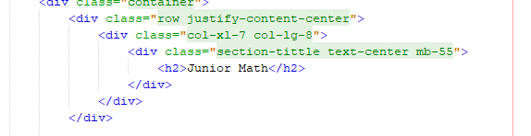

Figure 2: Example of HTML

HTML stands for HyperText Markup Language1) (translated as HyperText Markup Language) is used to create a web page, on a website can contain many pages and each page is defined as a HTML data (sometimes I will write it as an HTML file). The father of HTML is Tim Berners-Lee, also the creator of the World Wide Web and the president of the World Wide Web Consortium (W3C - the organization that sets standards on the Internet) (Domantas, 2019).

An HTML document is made up of HTML Elements (HTML Elements) which is specified by tag pairs, which are surrounded by a parenthesis (example) and will usually be declared. into a pair, consisting of opening and closing tags (for example and). The documents that want to be marked with HTML will be declared inside the tag pair (for example, This is bold text). But some special tags do not have a close tag and the declared data will be included in attributes (such as the tag). An HTML file will contain HTML elements and are saved under a .html or .htm extension (Domantas, 2019).

**Pros:**

* There are many resources to support an extremely large user community
* Can work smoothly in almost any browser today
* Learning HTML is quite simple
* The markup used in HTML is often short, with high consistency
* Use Open source, completely free
* HTML is a web standard operated by W3C
* Easy to integrate with backend languages ​​(eg PHP, Node.js, ...)

**Cons:**

* Applies mainly to static web only. If you want to create dynamic features, programmers have to use JavaScript or a 3rd party backend language (eg PHP)
* Each HTML page needs to be created separately, even when there are many duplicate elements such as header. , footer.
* It is difficult to control how HTML files are read and displayed by browsers (for example, some old browsers cannot render new tags. Therefore, even in HTML documents using these tags, browsers cannot read them). .
* Some browsers are still slow to update to support new HTML features

#### CSS

CSS stands for Cascading Style Sheets, it is a language used to find and reformat elements generated by markup languages ​​(eg HTML). You can simply understand that, if HTML plays the role of formatting the elements on the website such as the creation of text, headers, tables, ... then CSS will help us to add a little "style. "On those HTML elements such as changing the color of the page, changing the text color, changing the structure, ... (Morris, 2019)

The way CSS works is that it will look based on the selection, the selection can be the name of an HTML tag, the name an ID, class or many other types. It then applies the desired changes to the selection (Morris, 2019).

A CSS snippet is structured like this:

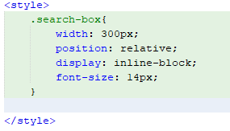

Figure 3: CSS example

That means it will be declared by selection, then attributes and values ​​will be inside curly braces {}. Each property will always have its own value, the value can be numeric, or value names in the CSS available list. Values ​​and properties must be separated by a colon, and each property declaration line will always have a semicolon at the end. A selection can use unlimited attributes.

#### Bootstrap

Bootstrap is a framework that allows designing reponsive websites faster and easier. Bootstrap is comprised of HTML templates, CSS templates and Javascript that make the basic ones available like: typography, forms, buttons, tables, navigation, modals, image carousels and more. In bootstrap there are more Javascript plugins in it. Makes designing your reponsive easier and faster (Ouellette, 2017).

The advantages of using bootstrap (Ouellette, 2017):

* Very easy to use: It is simple because it is based on HTML, CSS and Javascript only needs basic knowledge of 3 that is to be able to use bootstrap well.
* Responsive: Bootstrap's has built-in reponsive css on phones, tablets, and
* Mobile desktops : In Bootstrap 3 mobile-first styles is part of the core framework.
* Browser compatibility: It is compatible with all browsers (Chrome, Firefox, Internet Explorer, Safari, and Opera)

### Back-end

#### PHP

PHP - Hypertext Preprocessor understands Vietnamese PHP is a hypertext processor previously written as Personal Home Pages - personal home page. It is a programming language mainly used in the development of applications with a series of code written for the server or open source, for the purpose of developing web applications, websites. Static or dynamic web page. PHP scripts can only be interpreted on a server that has PHP installed. A PHP script file contains PHP tags terminated with the ".php" extension. The PHP programming language is suitable for web pages to be easily applied to HTML pages. Therefore, it is optimized for web applications with excellent features such as fast, compact, and similar in structure to C or Java. This is also considered to be an easy programming language to learn and faster than some other programming languages (Griffin, 2020).

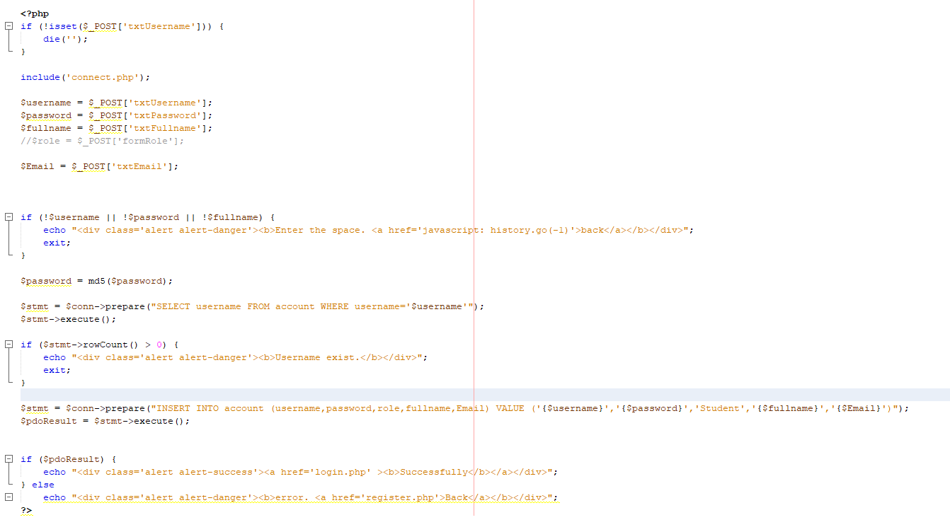

Figure 4: Example code for php

PHP primarily focuses on server-side scenarios, so you can do whatever any other CGI program can do, such as collect form data, create dynamic page content, or send and receive cookies. But PHP can do more than that. There are three main areas where PHP scripts are used (Griffin, 2020).

Set up a server program: This is the most traditional and primary target field for PHP. You need three things to do this: a PHP (CGI or server module) syntax analyzer, a web server, and a web browser. You need to run a web server, with a PHP installation connected. You can access php program input using a web browser, view the PHP page through the server. All of these can run on your server if you are just testing PHP programming. See the installation instructions for more information (Griffin, 2020).

Create a script line: You can create a PHP script to run it without any server or browser. You only need the PHP lumps analyzer to use it this way. This type of use is ideal for scripts that are frequently implemented using cron (on *nix or Linux) or Task Schedule schedule (on Windows). These scripts can also be used for simple text processing tasks. Create a working app: PHP is probably not the best language for creating a desktop app with a graphical user interface, but if you know VERY WELL about PHP and want to use some advanced PHP features in your client-side applications, you can also use PHP-GTK to write such programs. You also have the ability to write multi-platform apps in this way. PHP-GTK is an extension to PHP, not available in the main distribution. If you are interested in PHP-GTK (Griffin, 2020).

PHP can be used on all major operating systems, including Linux, many UNIX variants (including HP-UX, Solaris, and OpenBSD), Microsoft Windows, macOS, RISC OS, and maybe other variants. The PHP programming language has also supported most web servers today. PHP acts as a module or CGI processor. Therefore, PHP programming language, you have the freedom to choose an operating system and a web server. Moreover, you can also choose to use process programming or object-oriented programming (OOP) or a combination of both. With PHP, you are not limited to HTML input. Php's capabilities include exporting images, PDF files, ... created on the go. You can also easily export any text, such as XHTML and any other XML files. PHP can automatically create these files and save them in the file system, instead of printing them out, creating a server-side buffer for your dynamic content (Griffin, 2020).

One of the most powerful and most important features in PHP is its support for a wide range of databases. Writing an extremely simple database-enabled website using one of the database-specific extensions (e.g. for MySQL) or using an abstract class like PDO or binding connect to any database that supports the Open database connection standard through the ODBC extension. Other databases may use cURL or socket, like CouchDB. PHP also has support for talking to other services using protocols like LDAP, IMAP, SNMP, NNTP, POP3, HTTP, COM ( on Windows) and a multitude of other services. You can also open up terrestrial network sockets and interact using any other protocol. PHP has support for the complex exchange of WDDX data between virtually all Web programming languages. Talking about connectivity, PHP has support for instantiating Java objects and using them transparently as PHP objects. PHP has useful word processing features like Perl (PCRE), many extensions to allow users to access them. Access XML documents. The PHP programming language can be very useful for people (Griffin, 2020).

**Why should choose PHP?**

One huge advantage of the open source PHP language provides is the community. PHP is continuously developed and optimized by developers around the world making it extremely friendly to everyone and getting better and better. If you're looking for a specific scenario, chances are another user created something similar. Test in the PHP community and you can greatly shorten web design development time and website optimization yourself (Hussain, 2017).

PHP language is a dynamic open source, has evolved by a lot of people, web design using PHP is also easier, less time consuming. PHP uses less code, has optional built-in memory, so design results faster. PHP can also develop high level structures for complex websites with similar results as other languages. So, if you are wondering about the cost of web design, web design with PHP is an optimal choice (Hussain, 2017).

1. Open source

As many of you probably know PHP is an open source product (Open-source), installing and customizing PHP is free and free. Because of the advantage of open source, PHP can be installed on most popular Web Servers such as Apache, IIS .. (Hussain, 2017).

1. PHP Community.

As an open source language with the popularity of PHP, the PHP community is considered to be quite large and has quality. With a large development community, updating current version patches as well as testing new versions makes PHP very flexible in improving itself. Community support, sharing experiences of PHP is also very rich. With many forums, domestic and foreign blogs talking about PHP has shortened the learning process of PHP learners (Hussain, 2017).

1. Rich Library

In addition to community support, the PHP script library is also rich and varied. From very small ones like just a piece of code, a function (PHP.net ...) to bigger ones like Framework (Zend, CakePHP, CogeIgniter, Symfony ...), complete application (Joomla, WordPress, PhpBB ... ). With the rich code library, learning and applying PHP becomes very easy and fast. This is also the characteristic that makes PHP quite stand out and is also the reason why more and more people are using PHP for web development (Hussain, 2017).

1. Support for connecting multiple database systems

The need to build web using databases is an indispensable need and PHP also satisfies this need very well. With the integration of many Database Clients in PHP, the PHP application easily connects to popular database systems. Updating and upgrading Database Clients is simply the replacement of PHP extensions to match the database system that PHP will work with. Some popular database systems that PHP can work with are: MySQL, MS SQL, Oracle, Cassandra,.. (Hussain, 2017).

1. Object Oriented Programming

Nowadays, the concept of object oriented programming (OOP) is no stranger to programmers. With the capabilities and benefits of this programming model, many languages ​​were deployed to support OOP. From PHP version 5, PHP has been able to support most of the outstanding features of object oriented programming such as Inheritance, Abstraction, Encapsulation, Polymorphism, Interface, Auto load, ... With the growing number of frameworks and PHP applications are written in OOP model, so programmers can access and extend these applications easily and quickly (Hussain, 2017).

1. Confidentiality

PHP itself is the source code and the development community is very active so it can be said that PHP is quite safe. PHP also provides many mechanisms that allow you to implement security for your application such as sessions, data filter functions, casting techniques, PDO (PHP Data Object) library to interact with the database. whether more secure. Combined with security techniques at other layers, the PHP application will become more reliable and secure the website (Hussain, 2017).

1. Scalability for PHP

By being built on the C language and being open source, the ability to expand PHP applications is limitless. With its rich library and large scalability, PHP applications can interact with most popular types of applications such as image processing, data compression, encryption, PDF file manipulation, Office, Email , Streaming, ... You can completely build your own Extensions to optimize, add functions to PHP as well as optimize PHP's Core to serve the purposes of expanding your website (Hussain, 2017).

#### JavaScript

According to Morris (2019), JavaScript is a programming language that is supported in almost all browsers such as Firefox, Chrome, even mobile browsers. JavaScript can be applied in many areas:

* Website programming.
* Building application for server website.
* Mobile apps, apps, games.

When a web page loads, the browser parses the HTML and generates a data type called DOM from the content. The DOM represents the live view of the web page with JavaScript code. This code makes an update to the DOM and is presented to the user immediately. The browser also records UI events such as mouse movements, clicks, etc. Then, depending on the user's response, the code will do the programmed work accordingly. Using all of these utilities, you can build small applications to serve several allowed purposes (Morris, 2019).

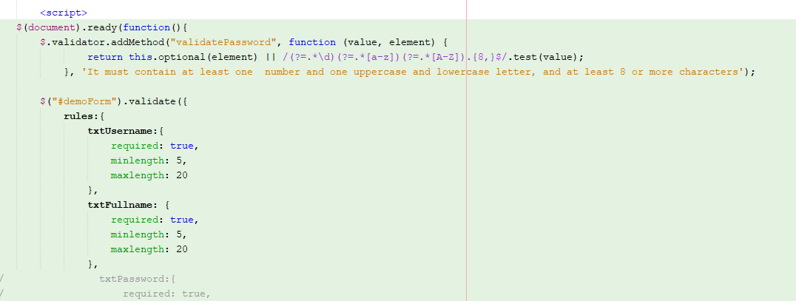

Figure 5: Example of JavaScript

Benefits of Using JavaScript (Morris, 2019)

* Client-side scripting implementations: With JavaScript, programmers can easily write client-side scripts, integrate scripts seamlessly into HTML, allow websites to interact, respond to users instantly, and create a visual interface.
* Server-side coding: Programmers can write server-side code in JavaScript.
* Simplify complex web application development: JavaScript allows developers to simplify the composition of applications, thereby simplifying the development of complex web applications.
* Responsive: JavaScript web design enables responsive web design - optimized on both desktop and mobile with just one set of code.
* Google AMP: To participate in Google's Mobile Page Acceleration (AMP) project, programmers must use the JavaScript programming language. You will understand more about Google AMP through the article: What is Google AMP?
* Many converters: Despite the lack of some complex features provided by modern programming languages ​​like Java and C #, JavaScript can still be easily extended using converters like CoffeeScript, TypeScript, DukeScript and Vaadin.

### Methodologies

#### Waterfall model

Waterfall Model is also known as a serial linear life cycle model. The waterfall model is one of the first software development models applied and very popular in the software engineering industry (toolsqa, 2020).

**Principle of Waterfall Modeling** (toolsqa, 2020)

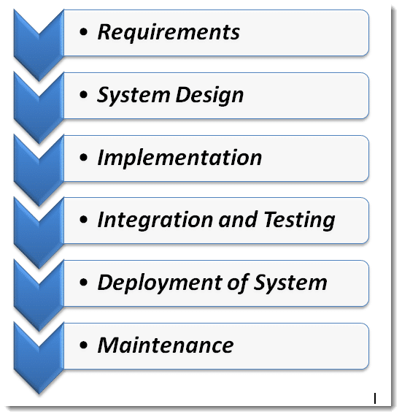

Figure 6: Principle of Waterfall Modeling (toolsqa, 2020)

**Step 1: Require and Analysis.**

Is a step conducting reading project requirements, analyzing the requirements that the project sets out. This is also known as the data collection step, writing on design documentation.

**Step 2: System Design.**

When step one is completed, step two is the beginning of documenting the design for the project. If step 2 is having trouble writing the design document, go back to step one to do it again.

**Step 3: Coding.**

Step 3 is done when step 2 is completed, programmers will base on the design documents, write code to create modules, functions for the software product.

**Step 4: Testing.**

Is the product test phase after coding is completed in step 3.

This test phase has many smaller stages such as: Unit Test, Program Test, Total Test.

Testing is an important stage in software development process in general and Waterfall in particular. It determines software quality when it is put to use.

**Step 5: Deployment.**

After the testing is completed, the software product is deployed, used, at the users, and in parallel with the monitoring process.

Users will send software bugs to manufacturers when they discover them during use.

**Step 6: Maintenance.**

As the process of software maintenance and maintenance, when the manufacturer discovers a bug, they will send it to the development team for modification and handling.

When the software upgrades to newer versions, changes functions, etc., the development team will do it and that is called maintenance software.

**Advantages** (toolsqa, 2020)

* Is a simple model, easy to apply, a step-by-step process.
* Easy to manage because it's fixed step by step.
* The stages are clearly processed and completed at the same time.

**Disadvantages** (toolsqa, 2020)

* The flexibility is not high, when a process is in the process of being executed, it detects a mistake, it will have to stop the whole thing, and go back to the first stage, to update the document again, and execute. back from that stage.
* There is no prototype product from the beginning, failing to meet service needs, selling and developing at the same time.
* High risk and poor reliability.
* Not suitable for projects with high complexity, long-term projects, or object-oriented projects (because objects keep changing properties over time).

**When to apply Waterfall?** (toolsqa, 2020)

* Apply Waterfall when it best understands the project's requirements, requirements are clear and have high stability.
* Mastering the developed technology.
* There are no ambiguous requirements.
* Rich development resources and high technical expertise.
* Suitable for small and short term projects.

#### Scrum

According to scrum (2020), Scrum is a management and process framework that solves complex problems, while ensuring efficiency, creativity, and the highest value of the resulting product. Scrum itself is a simple framework that enables the most effective coordination among development team members working on complex products. With Scrum, the product is built on a series of iterative processes (called Sprint). The sprints happen regularly, each sprint is an opportunity to learn how to adjust to achieve the best fit and results. Referring to Scrum is:

* Gentle
* Ease of Understanding
* Difficult to manage and master



Figure 7: Scrum framework (scrum, 2020)

When implementing Scrum, there are 4 important Meetings or Ceremonies that make up the structure in each Sprint as follows:

* Sprint planning: Project team planning meeting, to determine what to complete in Spring. next.
* Daily stand-up: Also known as “Daily Scrum”, a small 15-minute meeting per day to discuss work between the development team.
* Sprint demo: A sharing meeting where team members show what they did during that sprint.
* Sprint retrospective: A review, a look at the current sprint's work and failures, and to work out a better and more complete solution for the next Sprint.

A Scrum development team has slightly different components from the traditional Waterfall model, with three roles:

* Product Owner
* Scrum Master
* Development Team

In addition, because the Scrum development team is multifunctional, the “Development Team” will consist of Testers, Designers, and Ops Engineers.

Transparency, inspection, and adaptability are the three fundamental foundations of Scrum. Here are the reasons why Scrum should be used.

* Scrum allows the freedom to implement
* Scrum easy to learn and easy to use
* Scrum adopting the
* Scrum change reduces the risk of building a
* Scrum product that optimizes the efficiency and efforts of the
* Scrum development team to enable the customer to use it. use earlier than
* Scrum continually improves

### Recommendation system

Recommendation systems (Recommender systems or Recommendation systems) are a form of decision support systems that provide a personalized solution without going through a complicated search process. Suggestions learn from users and suggest the best products out of the box (Seif, 2019).

Suggestions use product knowledge, expert knowledge or exploration knowledge learned from human behavior to make recommendations about products they like in thousands of thousands of products. Products in the system E-commerce websites, such as books, movies, music, use a suggestion system to provide information to help users decide which product to choose. Products are recommended based on the number of products that have been sold, based on the personal information of the user, based on the user's analysis of previous purchase behavior to make predictions about the customer's own future buying behavior. Suggestions include suggesting products to consumers, personalized product information, summarizing public opinion, and providing shares, reviews (Seif, 2019).

There are a few recommender systems the following:

|  |  |  |  |
| --- | --- | --- | --- |
| Recommender systems | Baseline data | Output data | Processing process |
| Based on collaborative filtering | The ratings of the users in U for the objects in I. | The rating of u for the objects in I. | Recognize the user in U similar to U (about preference) and then extrapolate u's rating to I. |
| Based on the content | The characteristics of the objects in I. | U's rating scores for the objects in I. | Create a model that describes the preferences of the user u, then use it to evaluate preferred level of u with i. |
| Based on knowledge | The characteristics of the objects in I. | Knowledge (knowledge) about the suitability of the objects with the needs of the user. A description of the user's needs and preferences u. | Inference between I and the needs of the u. |

Table 1: Recommender systems (Seif, 2019)

1. Recommender systems based on collaborative filtering

Recommender systems based collaborative filtering : the suggested method is the most widely deployed and most successful in practice. The filtered system analyzes and synthesizes the subjects' rating scores, recognizes similarities among users on the basis of their rating and generates suggestions based on the this comparison. A typical user profile in a collaborative filtering system consists of a vector of objects and their rating scores, with the number of dimensions increasing continuously as the user interacts with system over time. Some systems use a time-based discounting approach to calculate the “slip” factor of user interest. In some cases the rating can be binary (like / dislike) or real numerical values ​​indicating priority (Seif, 2019).

The greatest strength of collaborative filtering is that they are completely independent of the representation of the object being suggested, and can therefore work well with complex objects such as sounds and movie. Schafer, Konstan & Riedl (1999) refer to collaborative filtering as "people-to-people correlation" (Seif, 2019).

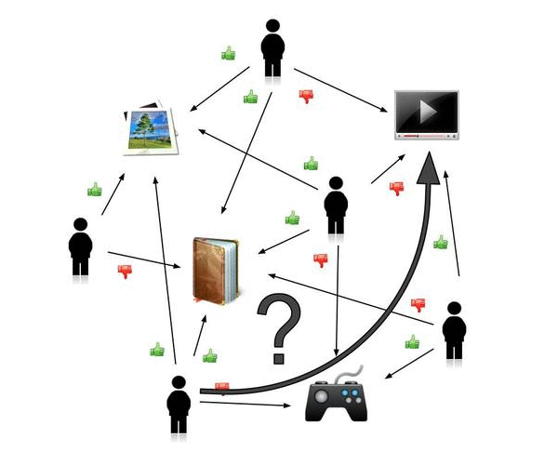

Figure 8: Collaborative filtering process (Seif, 2019)

**Pros:**

* Multi-category capability
* No need for domain knowledge
* Quality increases over time
* Enough negative feedback

**Cons:**

* New user
* Problem about New product / audience
* Quality The amount depends on the size of the user operation history data.
* The issue of sustainability and flexibility

1. Recommender systems based content suggestions

Recommender systems based on content (Content-based recommendation systems) is the successor and expansion of research fields to filter information. In the system, the objects are represented by the characteristics associated with them. For example, text suggestion systems such as the NewsWeeder news filtering system use words from texts as features. Some content-based suggestion systems learn a profile of a user's interests based on characteristics that appear within the rated user audience. Schafer, Konstan & Riedl refer to the content-to-item correlation as the content-to-item correlation. The user profile of a content-based suggestion system depends on the method of machine learning used (Seif, 2019).

Decision trees, noron networks (neural nets), and vector-based representations can all be used to learn user profiles. As in collaborative filtering, user profiles in content-based suggestions are permanent data that is updated over time (Seif, 2019).

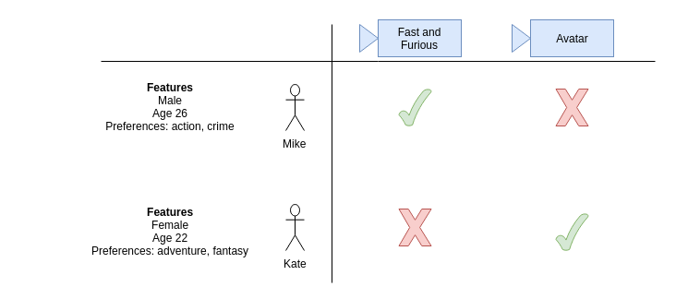

Figure 9: Recommender systems based content suggestions (Seif, 2019)

**Pros:**

* No need for domain knowledge
* Quality increases over time
* Enough of inconclusive feedback

**Cons:**

* Problems of new users
* Quality depends on the size of user action history
* Problems sustainability and flexibility

1. Recommender systems based on knowledge

Recommender systems based on knowledge: suggest objects based on inferences about the needs and preferences of the user. In a sense, all suggestion techniques can be described as doing some inference. Knowledge-based approaches are distinguished in that: they have the knowledge of how a particular object meets the needs of a particular user, and can therefore argue about the relationship between specific needs and suggestions. Use a clear domain of knowledge that is relevant to the relationship between a user's requirement and a particular product. Initially, people give three types of knowledge: catalog knowledge (knowledge of the suggested product), user knowledge (knowledge of the user's requirements) (Seif, 2019).

This method is not based on the user profile, so there are no problems with the new product and the new user. Suggestions on the basis of knowledge are capable of deduction, deduction ability depends on the suitability of the user's requirements with the product attributes (Seif, 2019).

Every knowledge-based system is a relationship of acquiring knowledge. In fact, the quality of the suggested options depends on the accuracy of the knowledge base. This is also the biggest limitation of this method (Seif, 2019).

**Pros:**

* Can map between user needs and product / audience

**Cons:**

* Need to gather knowledge

### Conclusion

Through the above summary of some font-end and back-end programming languages ​​as well as some methods for developing a project, I can come up with options for this project. Firstly, for the back-end, I decided to use php as the main language because it is a common language for designing website systems today, with open libraries to support the development Web. Next on the font-end section, html and css will be the best choice for website design and it has very good interaction with php. Next, the project development method, for this project I will choose the water fall model because this is a simple, easy-to-implement method for small and medium projects that is very suitable for this project. Finally, on the Recommender systems, I decided to choose the Recommender systems based on collaborative filtering this is the suggestion system that is best suited to this case study because it helps gather information about user habits to help develop better systems.

## Other systems

Currently, many systems have been created to serve the needs of online learning. In this section I will introduce some of these systems.

### Future learn

Link website: <https://www.futurelearn.com/courses>

FutureLearn is a web-based online learning system. They collaborate with universities around the world, making it easier for people with learning needs around the world to develop new skills and achieve their personal and professional goals quickly and most convenient.

With a user-friendly main interface, streamlined toolbars make it easy for users to choose the feature they want without being obstructed and time consuming in user tasks. the search toolbar and the log-in and registration buttons are arranged reasonably so that users can easily register and find information about the class they want.

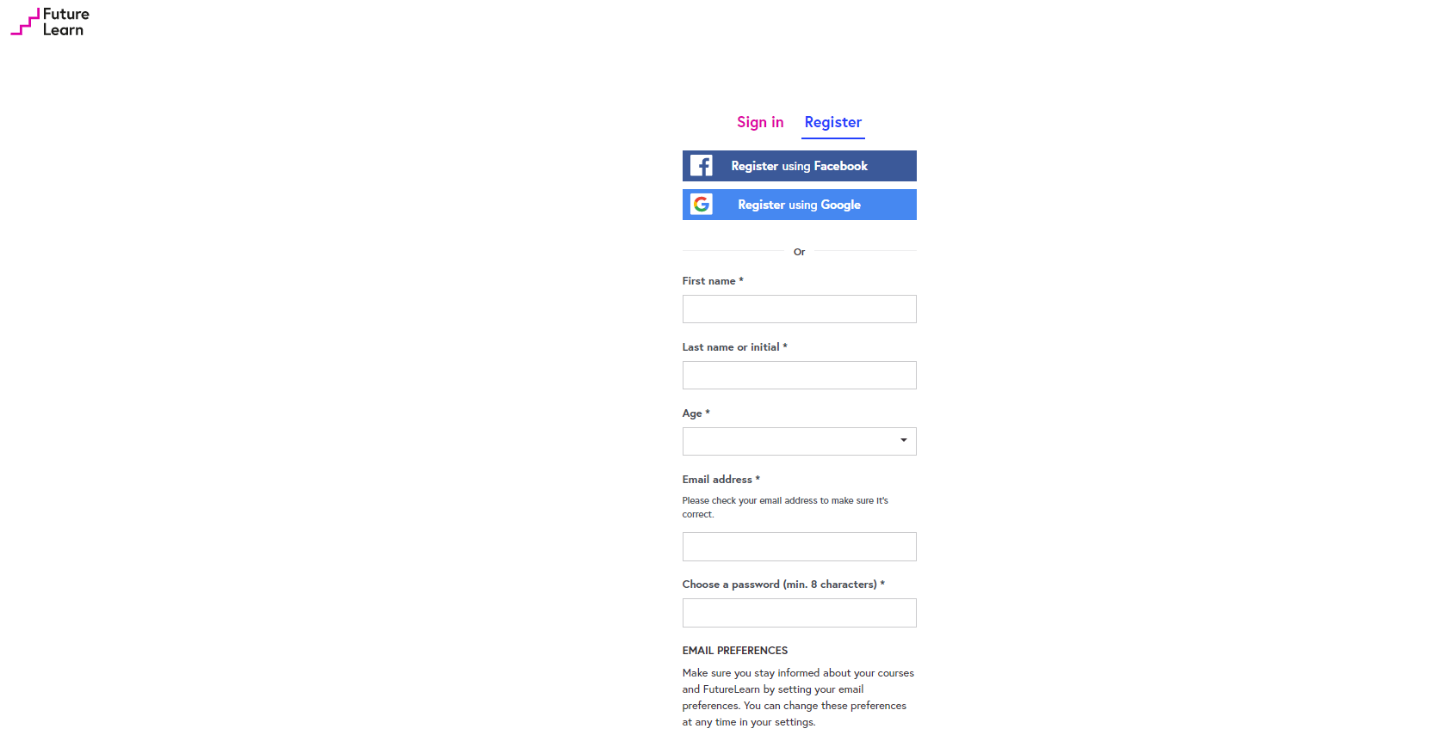

Figure 10: Futurelearn login (https://www.futurelearn.com/courses)

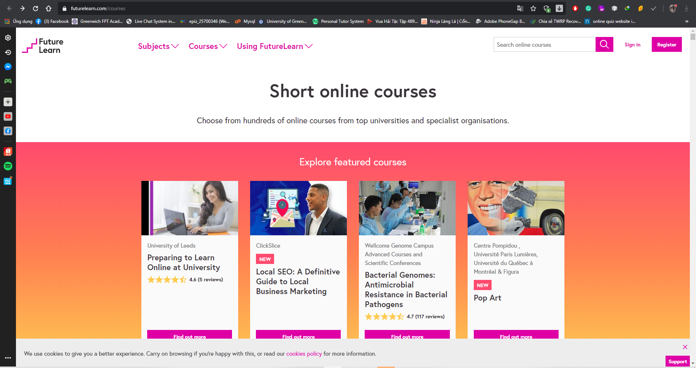

Figure 11: FutureLearn homepage (https://www.futurelearn.com/courses)

Their website offers a wide variety of subjects in many fields such as law, IT, art ... This makes their website more diverse and lively. Users will find their favorite subject easily. With this variety of disciplines, they can easily compete with other online learning systems.

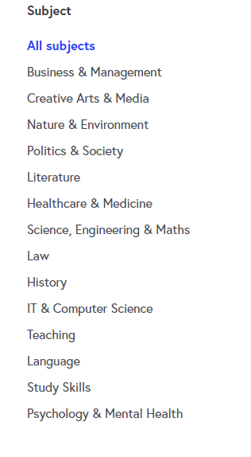

Figure 12: Subject menu(https://www.futurelearn.com/courses)

When you click on an existing class, the class overview will appear. The title and illustrations are very eye-catching, attracting users. If you want to join a class, you can click the join button to add classes, which is very convenient for users. In addition, below we can see an overview of this subject, what will be in the subject, and what it will be achieved. This makes it easier for users to make their choices for the subject.



Figure 13: FutureLearn course detail(https://www.futurelearn.com/courses)



Figure 14: Futurelearn course detail(https://www.futurelearn.com/courses)

Finally, we will discuss payment methods for future learn subjects. They give us three options in order to experience their service. There are three packages: Free, upgrade, Unlimited. With the free package, we can experience that subject for 6 months completely free of charge. This is a solution that helps increase users' attention to the system. The upgrade package will let us study the chosen subject forever until it is no longer available in the system. The other package allows us to experience all subjects comfortably for an unlimited year. Thereby, this system gives us many convenient payment packages for users to decide.

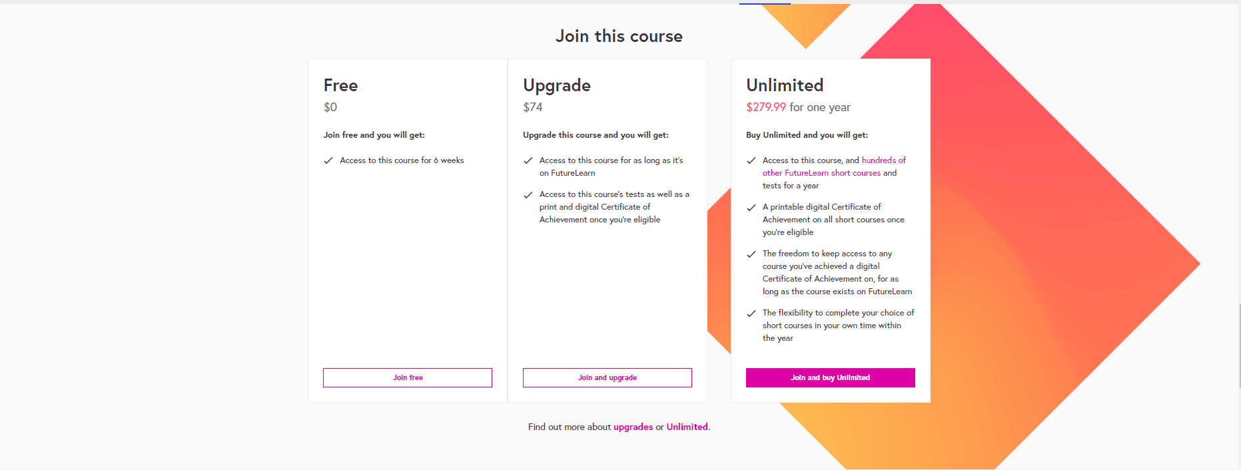

Figure 15: Futurelearn Payment(https://www.futurelearn.com/courses)

Thus, Future learn is one of the quite intuitive systems for online learning models, they provide a lot of subjects as well as a user-friendly interface. This is a system worth learning and applying to this project.

### Edx

Link: <https://www.edx.org/>

EdX is a reliable platform for education and learning. Founded by Harvard and MIT, edX is home to more than 20 million students, the majority of the world's top-ranked universities and industry leaders. As a global nonprofit, edX is transforming traditional education, removing barriers to cost, location, and accessibility. Meeting the needs of people to learn by themselves in their terms, edX is re-envisioning educational possibilities, providing the highest quality, stackable learning experience including groundbreaking MicroMasters® programs. Supporting students at every stage, whether entering the job market, changing fields, seeking promotion opportunities or exploring new concerns, edX offers courses for curious minds on topics from data and computer science to leadership and communications.

Edx has a fairly simple interface, not too colorful and user friendly. Subjects are neatly arranged, clearly showing the classes with each subject. As can be seen, they provide users with a lot of subjects that are attracting attention in the present day, typically mechine learning.

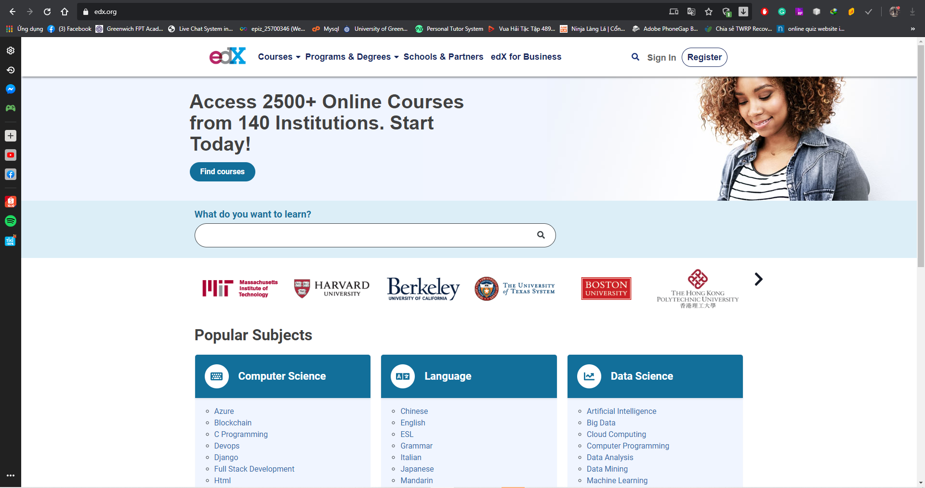

Figure 16: Edx homepage

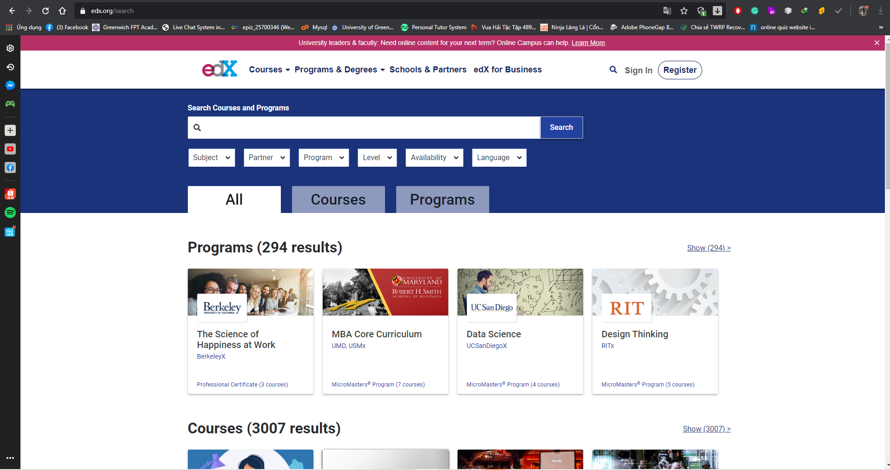

Figure 17: Edx all course

With the edx model, the subjects will be organized in the form of classes. The course will have a start time announced in the details as well as the time of study, the instructor of the course, and the language used. With edx, they charge a fee if the user wants a certificate confirming their completion of this course. And taking classes is completely free. This is a pretty practical model that can provide users with certificates, making online learning more practical.

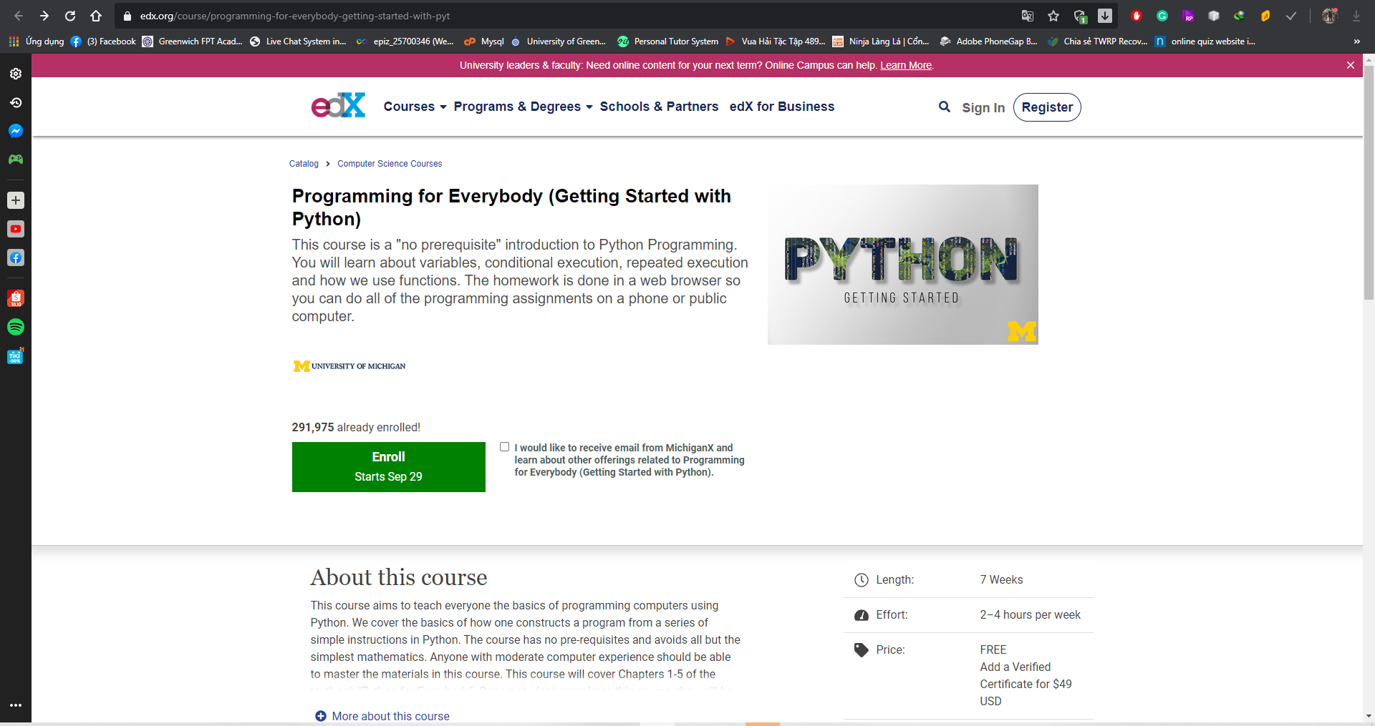

Figure 18: edx class detail

Thus, edx is an online learning system with a variety of disciplines, attracting many students every month with their online classes. Besides, their interface is quite friendly and easy to learn.

### Conclusion

The above-mentioned systems are quite popular and attract users to join their system every month. So their products are very reliable and learn to build the system of this project.

First, the two products have a user-friendly interface; the intelligent interface block arrangement makes it easy to use without the need for manuals. Second, all subjects have an eye-catching title, illustrations as well as a clear course overview that makes it easy for users to make their own decisions. Third, these sites cooperate with many famous professors and doctors to help stimulate users to join their system. Finally, the payment method for the subjects is very reasonable, supporting users to register monthly.

Besides, these products have some disadvantages. Too many subjects can affect the management and quality of the subjects. These systems do not have a communication function between teachers and students (chat, video calls), which can be a bit difficult for users to ask questions.

# Requirements analysis

Through finding out about online learning products on the market, it can be seen that the online learning market is growing. It can be seen that a pandemic in 2020 has spurred demand for online learning to soar. Therefore, we need to analyze some of the requirements that make online learning products successful. With this system, users will be divided into two main roles: students and teachers. As a teacher:

* Teachers need to be signed by the staff. This helps improve the security of the system avoiding junk accounts created from people who are not authorized.
* Teachers can log on to the system with the account created. The system will provide a teacher-specific interface, convenient to use.
* Teachers can create classes for themselves. These classes will be displayed in their page.
* Teachers can post videos of lectures as well as attachments to their created classes.
* Teachers can add comments in their classrooms.

For student users:

* Students can create a math account online. This allows students to log in as well as buy card packages to participate in online classes.
* Students can log into the system.
* Students can top up the system so they can pay to attend classes.
* Students can participate in classes that are on the system created by teachers.
* Students can download materials, view lectures, and classroom commentary.
* Students can search for teachers.

Below is the user case that will give us a better overview of this online math learning system.

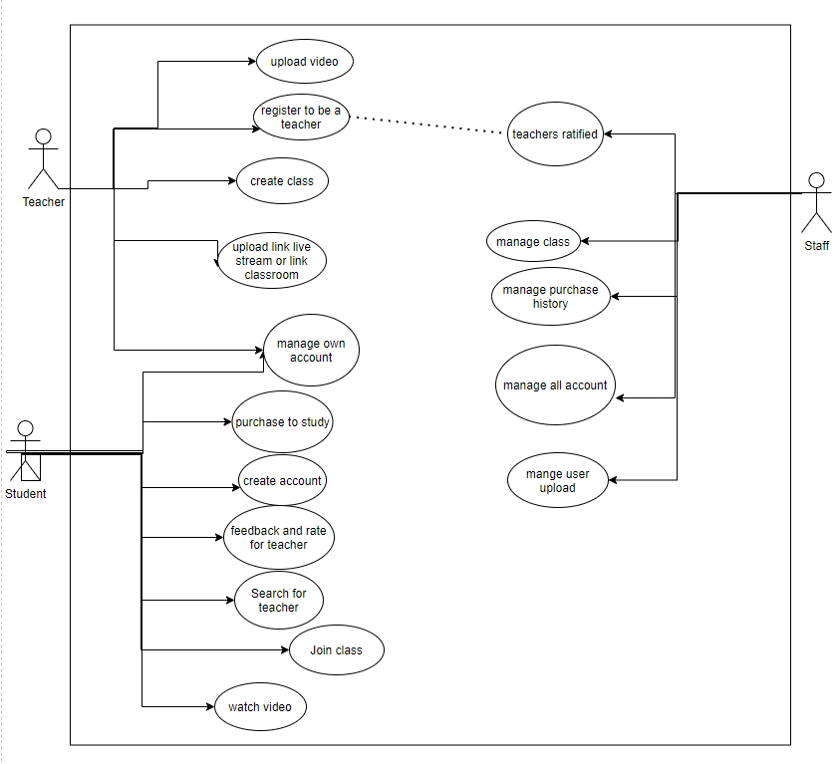

Figure 19: user case diagram

Thus, the above requirements will help us to perfect an online learning product. The role division will help the system had better manage as well as increase the user experience. The system will fully provide a user's needs when learning online. This helps to bring the best user experience.

# Design of math online system

## Entity relationship diagram

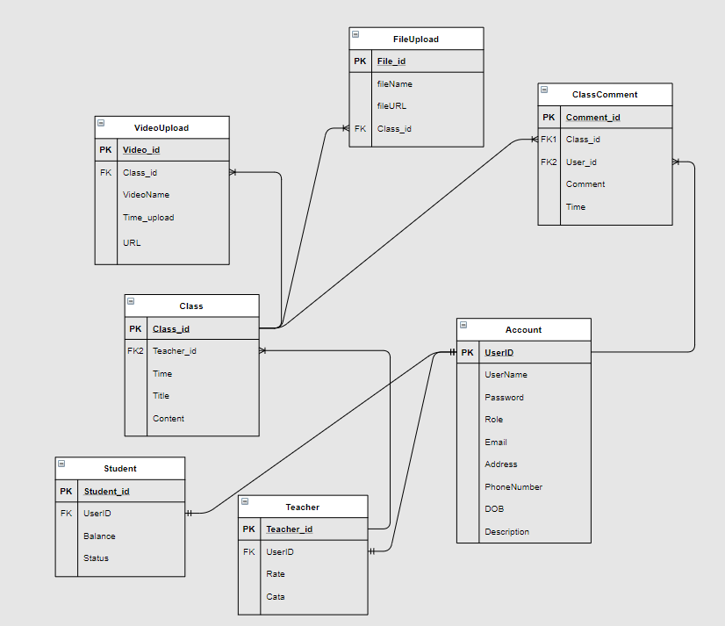

To design the database for the online math system first I will design entity relationship diagram. This diagram includes the main tables that will appear in the system database.

The first is the Account table. This table will store all of the user's accounts including the user's account name, password, role, and some other basic user information. This is the central table of this system. It will control the user's data as well as user id to other tables that make the system work. The second is the Teacher table. This table helps to separate teachers to optimize the system as well as help control teachers better. Here there will be some basic teacher information to help separate from the account table above. The third is the student table. This table will be separate from the student role, which stores the student's payment information and payment status. The fourth is the class table. This table is the central table of class functionality. This table will contain the teacher's ID, class creation time as well as the title and content of the class. The fifth is the upload video board. This table will be responsible for storing information about teaching videos that teachers upload to their classrooms. Next is the file upload table. This table is also responsible for storing information about class document files. Finally, the class comment table will have the task of storing the comments of each class.

## Write Frames of High Level Requirements

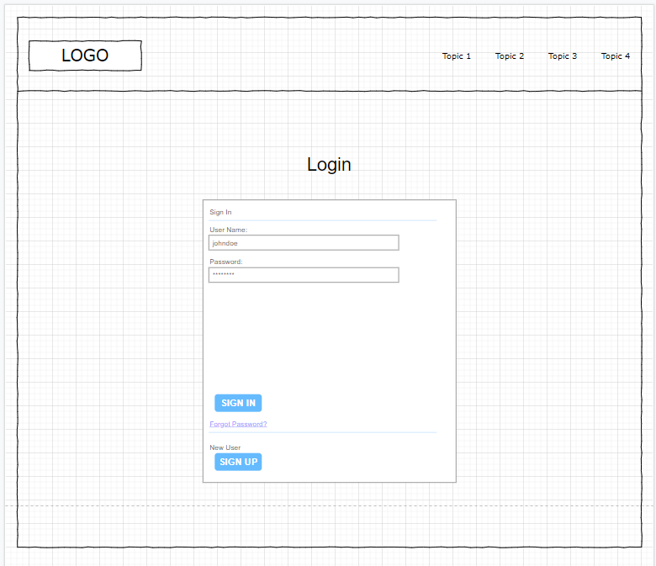

Figure 20: Frames of login

This is the interface of the login function to help users log in. This interface is expected to be designed to make the basic user easy to use.

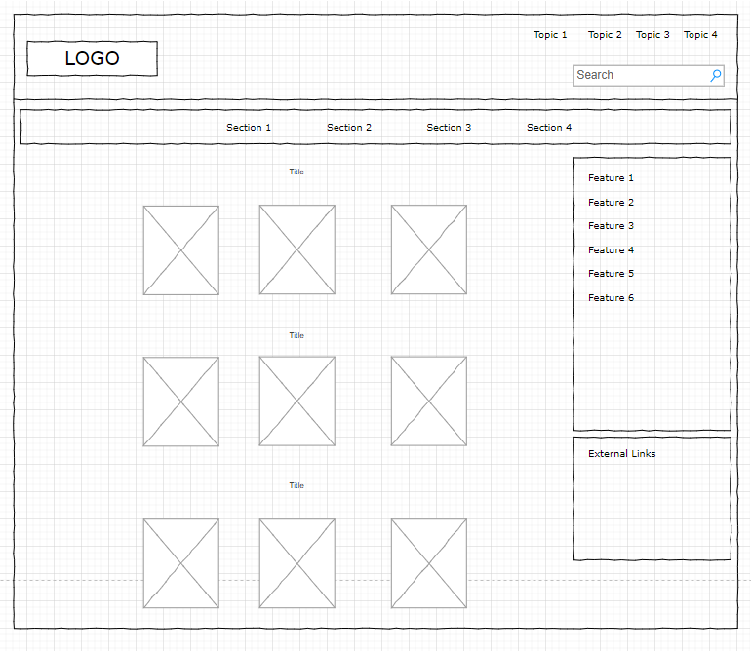

Figure 21: Frames of home page

The main interface I will design is to show the math teachers of each level. Helps users easily choose the right teacher.

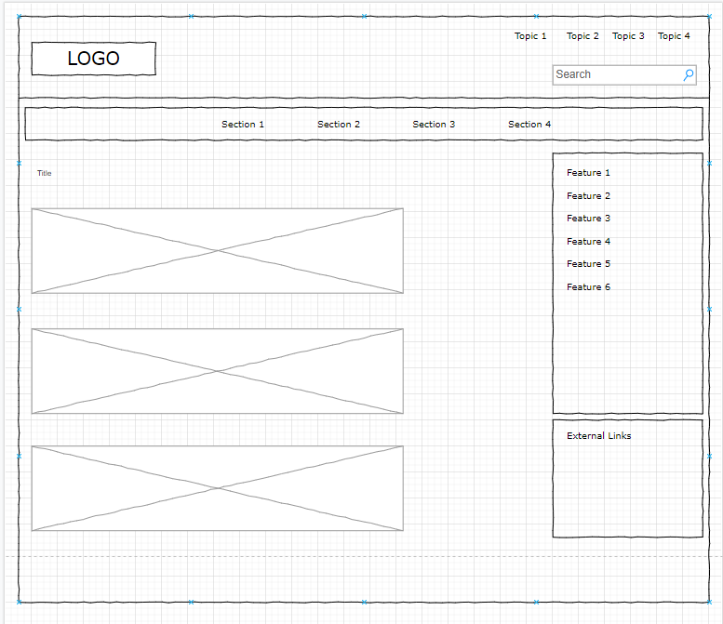

Figure 22: Frames of view class

The main interface I will design is to show the math teachers of each level. Helps users easily choose the right teacher.

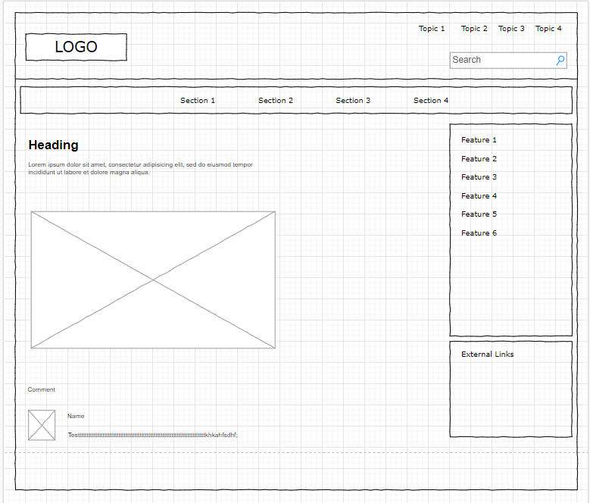

Figure 23: Frames of class detail

The classroom interface will have the information that the teacher adds to his class such as video, content, title as well as class comment.

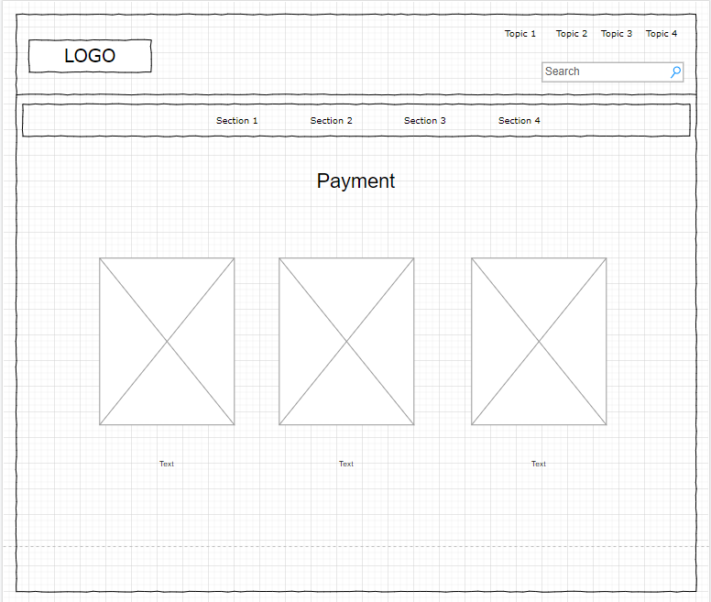

Figure 24: Frames of payment

Finally, when users decide to join the classes they will be redirected to the checkout page so that they can make their own payment decision.

# Development of the system

As a technology choice in literature review, I will use php for backend and html css for frontend. NetBeans IDE will write these two languages. In the process, I will run web testing using xampp and MySQL. The following I will introduce and analyze my system after it has been completed.

## Login form

When a user visits the website, the main interface will display buttons so that users can choose to register or login.

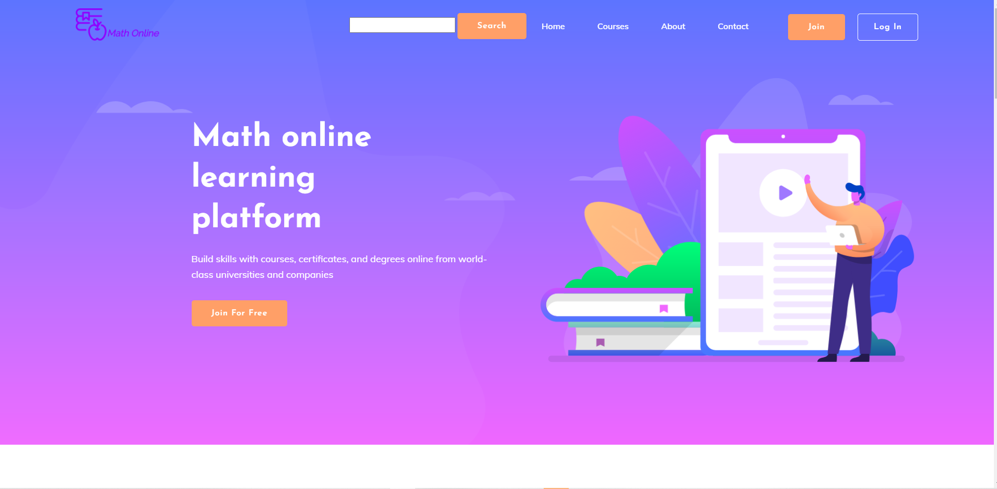

Figure 25: home page

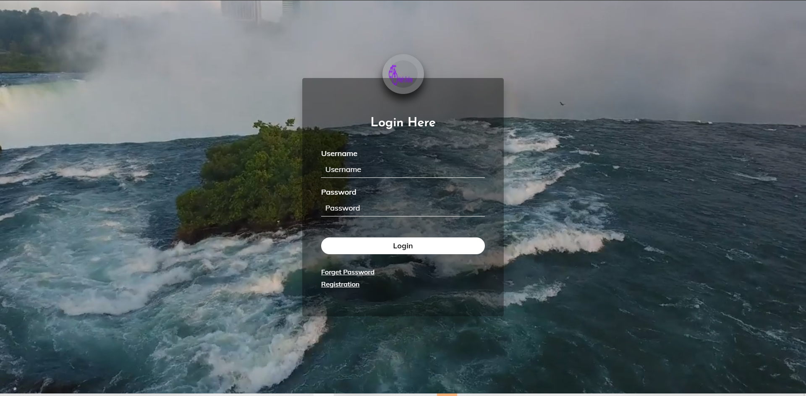

Figure 26: login form

When the user chooses to log in, the website will go to the login interface. Here I design the live wallpaper behind the login form. With this login form, the user will enter the username and password they created earlier. After entering, the user will press the login button to be able to login and redirect to the system homepage in the logged-in state. In case the user entered incorrectly, a message will appear asking the user to re-enter it. If the user does not have an account, they can click on the registration text to be redirected to the account registration interface.

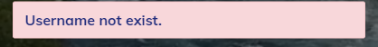

Figure 27: error alert

## Register form

After users choose to register in the login form or main interface, the system will switch to the registration interface. Here the user will need to fill in some basic information such as username, password, email, full name to be able to complete the registration form. The system will check for errors for the user. If incorrectly entered, a message will appear in each field. This will make it easy for users to register without having too many errors.

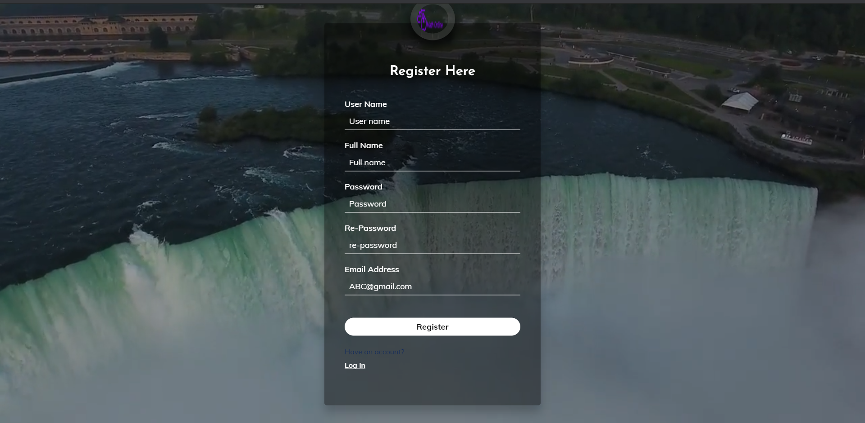

Figure 28: Register form

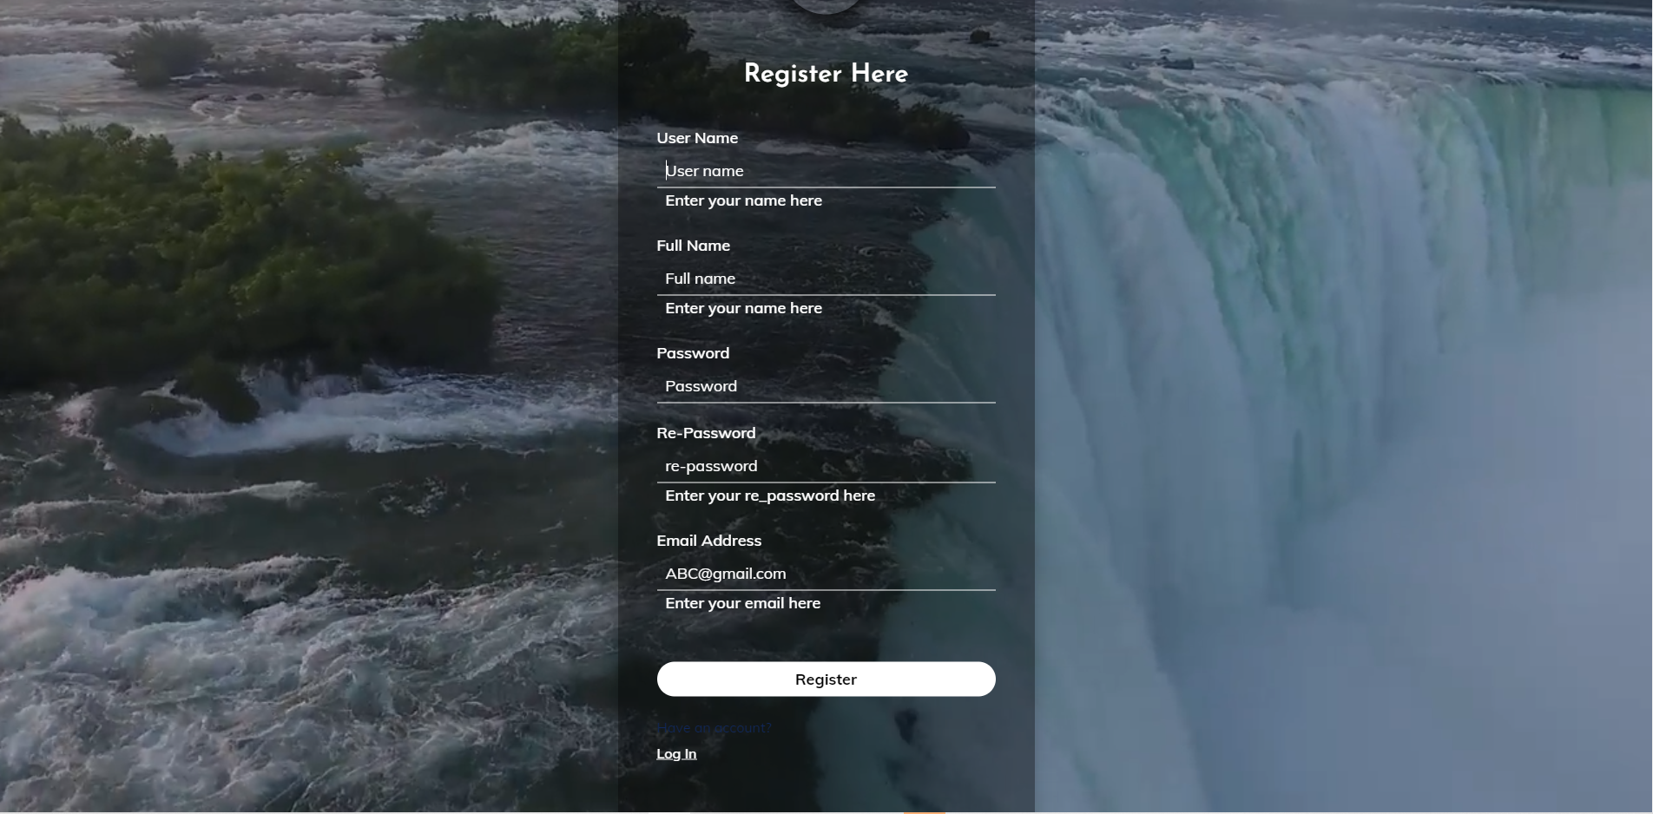

Figure 29: validation register

## Home page

When a user has registered their account and logged in, the main interface will be displayed with the login account status. There will be a banner introducing the system.

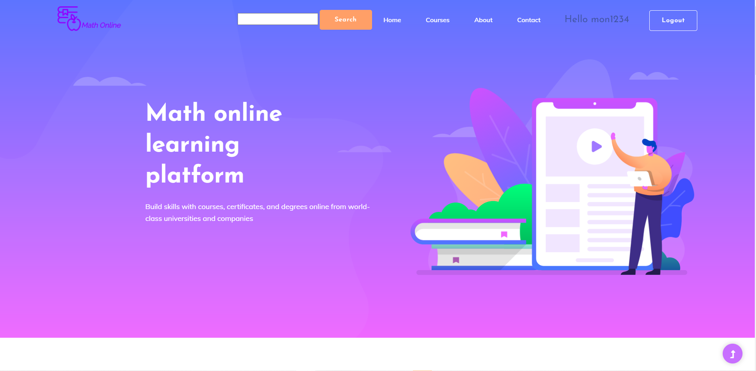

Figure 30: Home page

When scrolling down, there will be three main groups of math classes: primary, junior and high math. Teachers will teach in each of these sections. Users can view information about them. Users can choose an option and click on the details to view their classes.

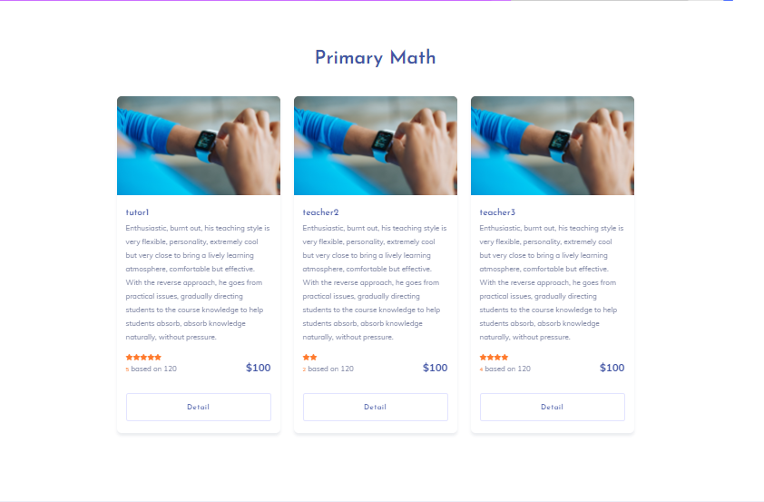

Figure 31: Home page

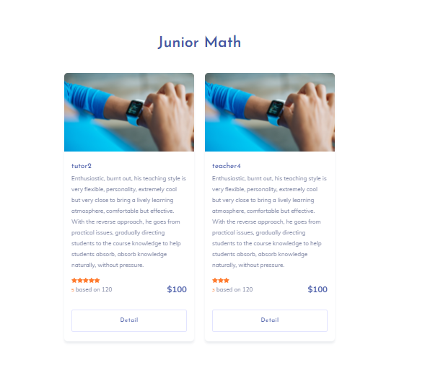

Figure 32: Home page

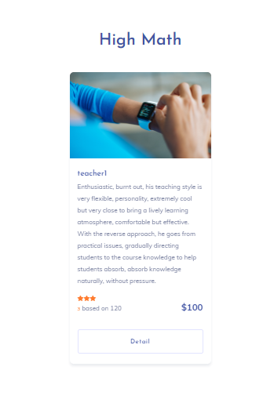

Figure 33: Home page

The navbar will appear in all pages of the system. This page will contain the search bar as well as the quick info box for your account. Here the user can view some basic information of the account such as the account balance, how long the account is from school. In addition, users can access their personal info page.

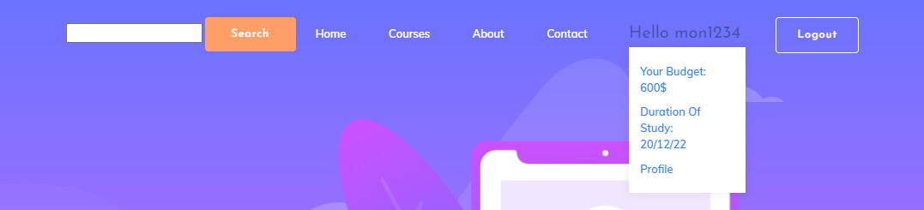

Figure 34: navbar

## All class

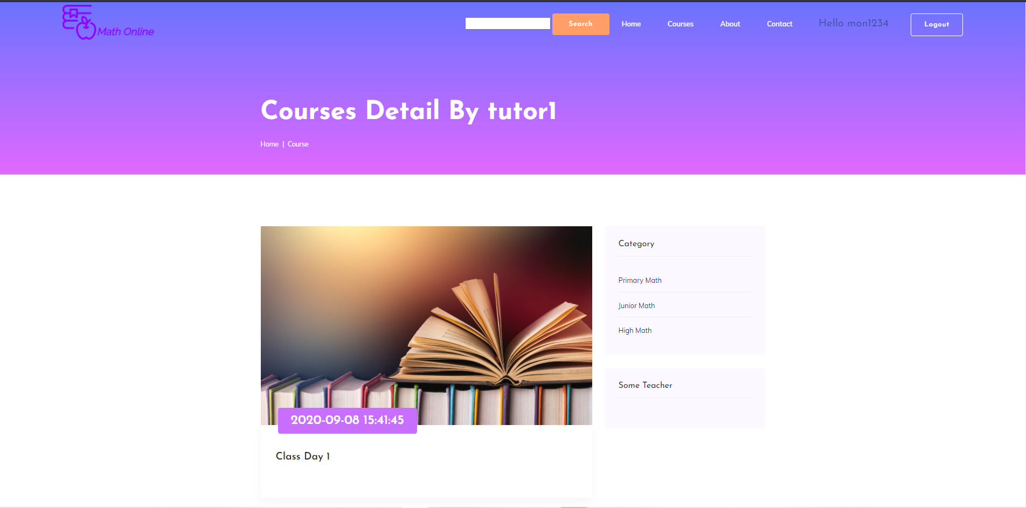

Figure 35: All class

This is the interface when the user clicks on any teacher. This interface will contain all the classes that teacher has created. The user selects the desired class through the title of each class.

## Class detail

Here will be the main interface of the class. Users can view all things related to the class such as title, class creation date, and lecture videos of the class and document files. Users can leave comments in the classroom and teachers will be responsible for resolving them.

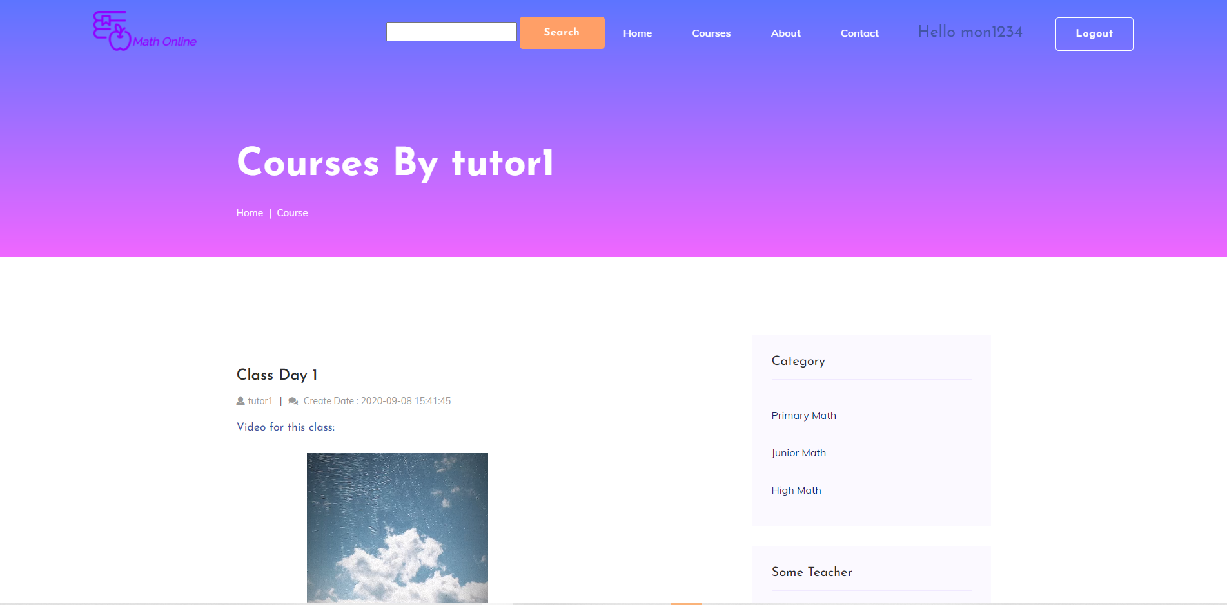

Figure 36: Class detail

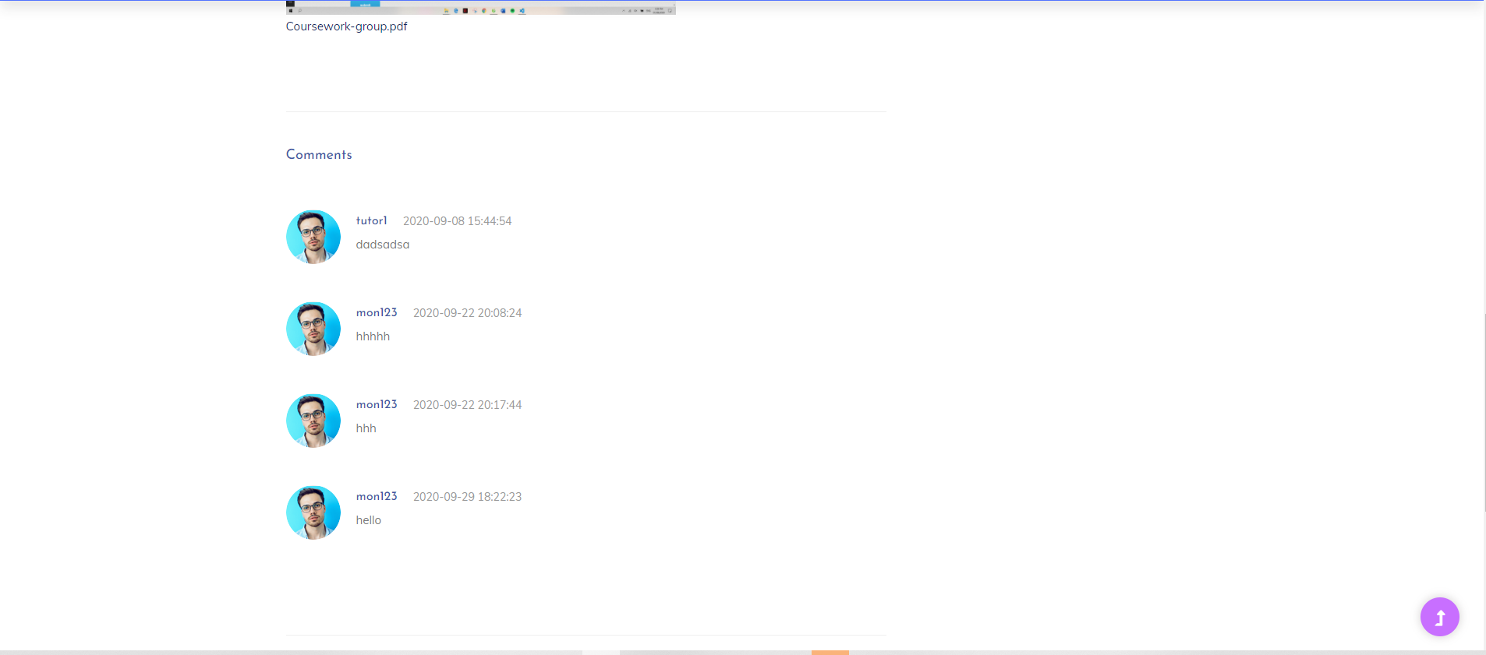

Figure 37: Class detail

## Payment

Because this system requires users to top up to buy a course package. So this is the user payment interface. Once logged into the payment methods the user will select the required deposit amount and press payment to top up their account.

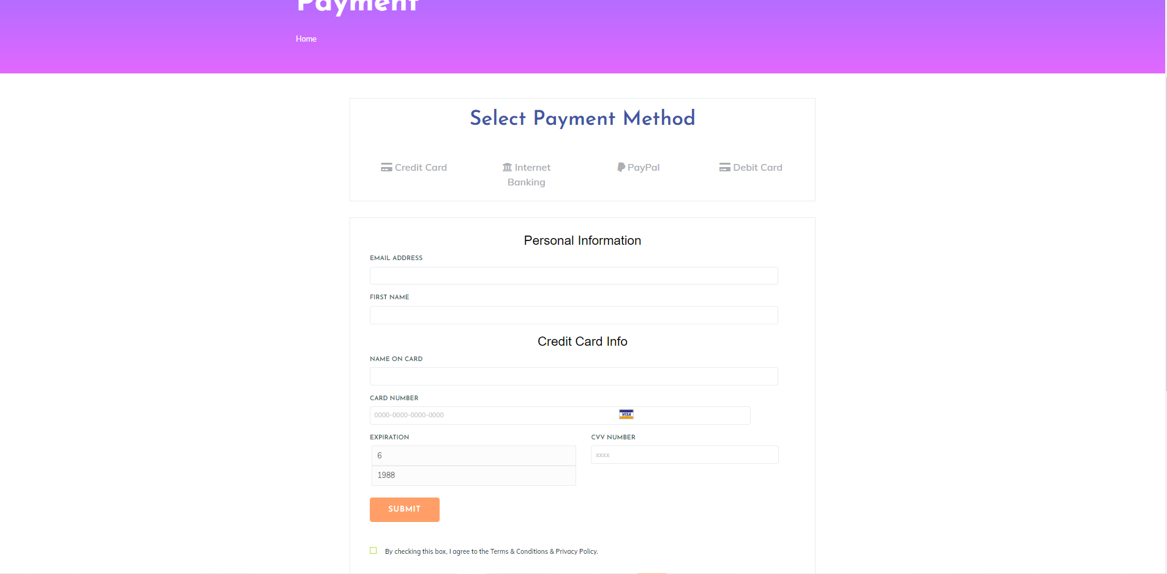

Figure 38: payment

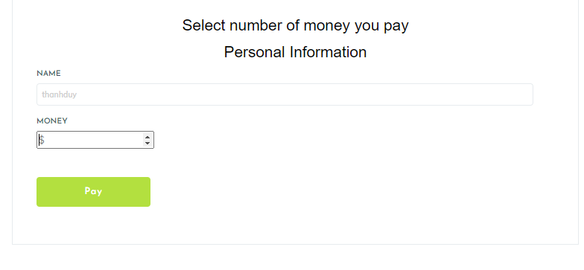

Figure 39: payment

## Extend

Once the account has been fully funded, the user needs to renew to be able to join the class. A table showing the amount in the account, the payable amount, and the user's balance is displayed here.

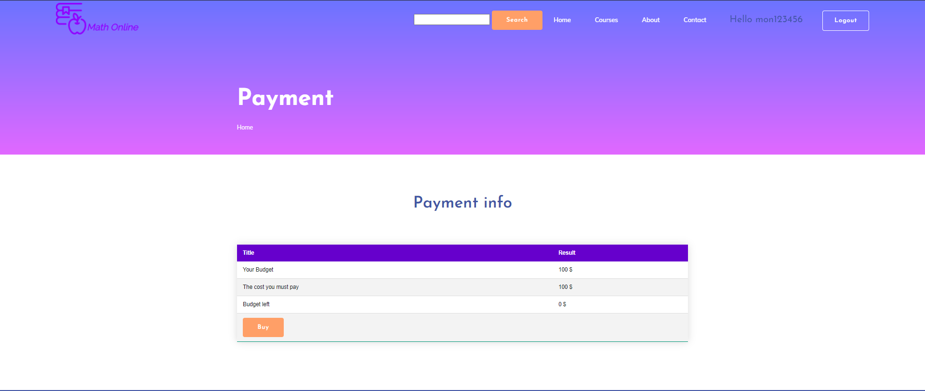

Figure 40: Extend

## Student profile

This is the interface of the user's personal page, and you can press the edit button to update your personal information.

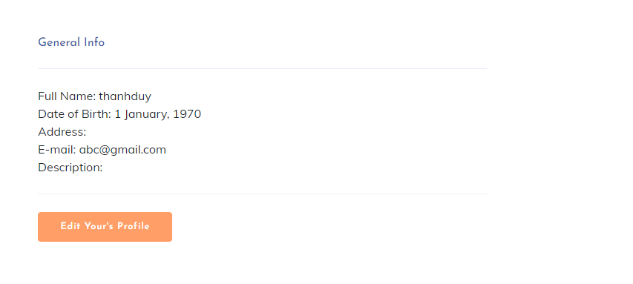

Figure 41: student profile

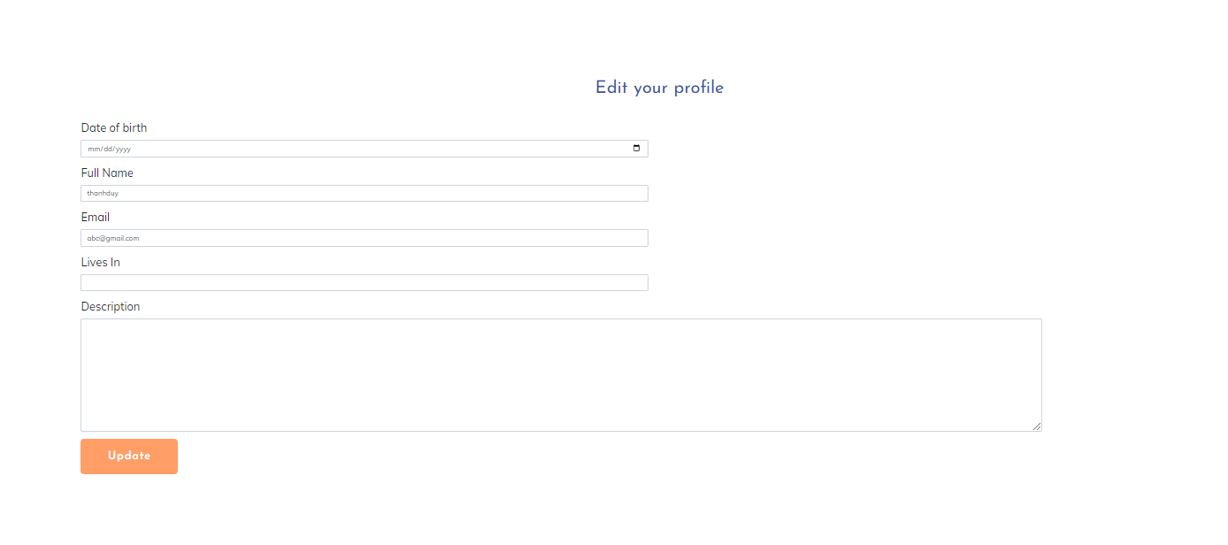

Figure 42: edit profile

## Home page – Teacher, staff

Staff and teachers will have a different main interface from normal users. Here will be some main functions to support them. The teacher will have the class creation interface and the staff will have control over the user's role.

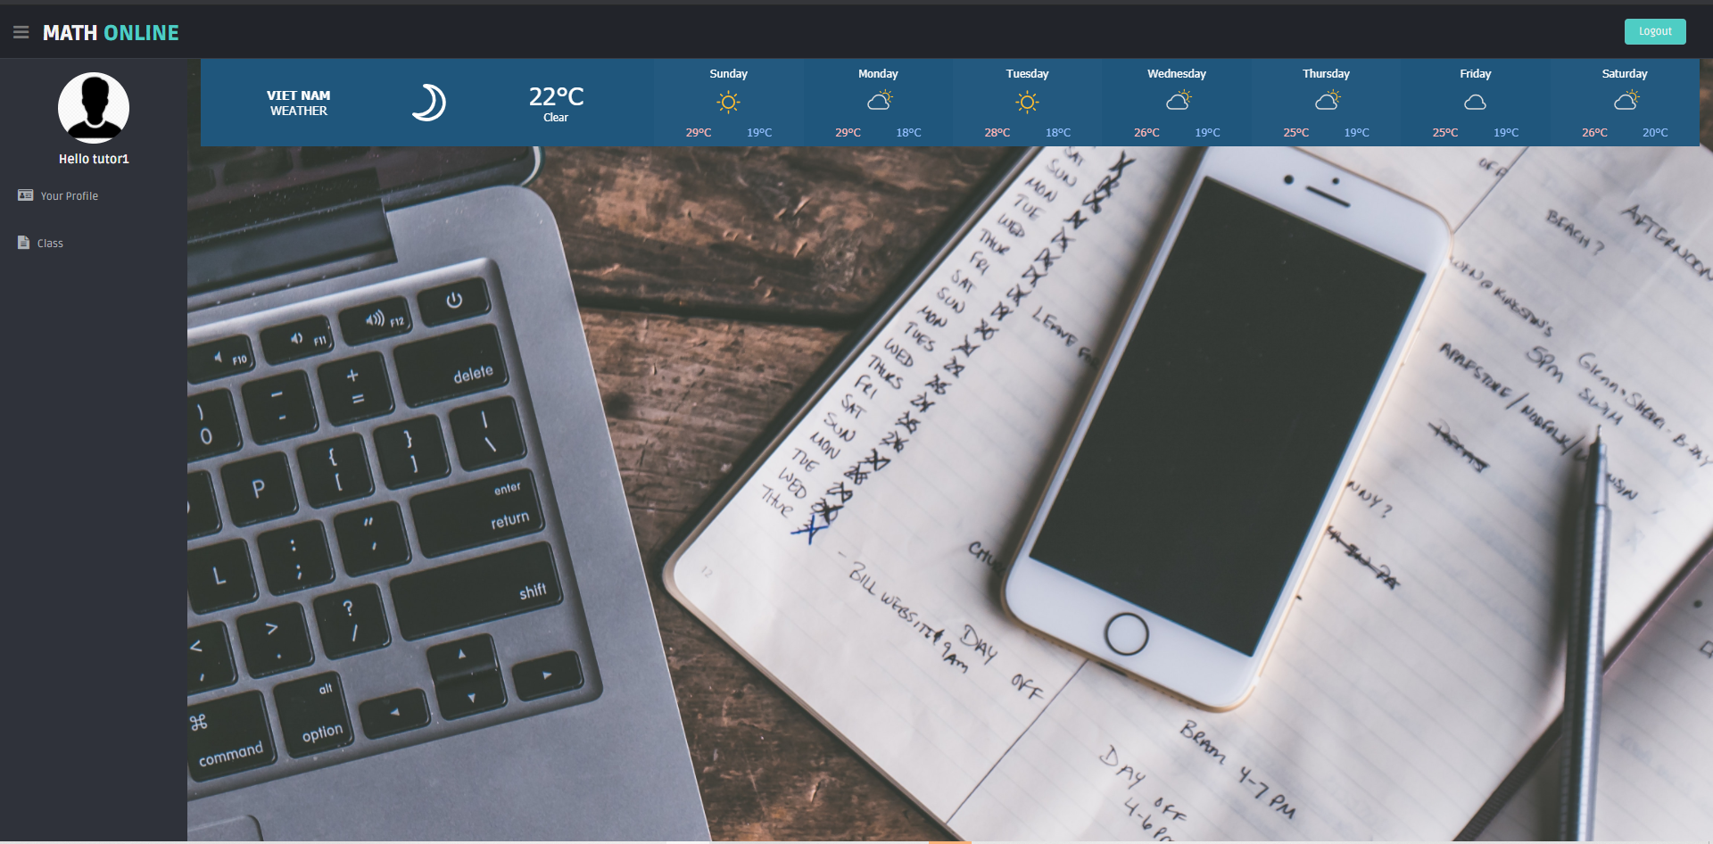

Figure 43: Home page – Teacher, staff

## Add new class – teacher

Staff and teachers will have a different main interface from normal users. Here will be some main functions to support them. The teacher will have the class creation interface and the staff will have control over the user's role.

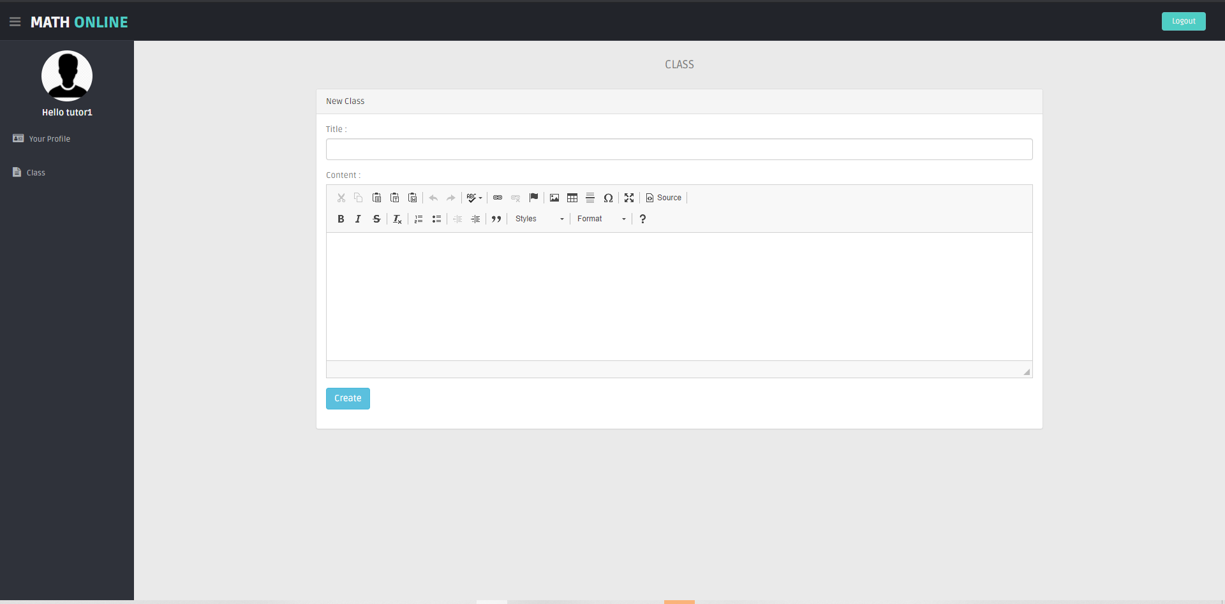

Figure 44: Add new class – teacher

## All class – teacher

In this interface the teacher can view all of their classes. Teachers can delete or open their classrooms.

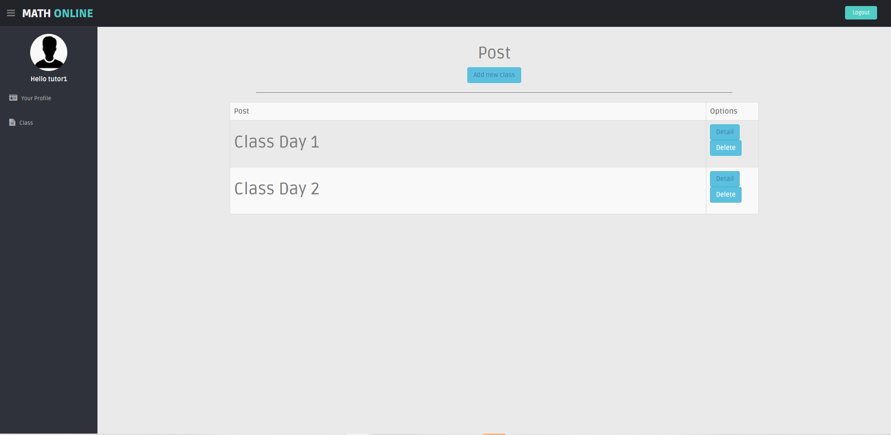

Figure 45: All class – teacher

## Class detail – teacher

This is a detailed view of a class managed by a teacher. The teacher can edit the class title and content as well as add lecture files and videos for the class.

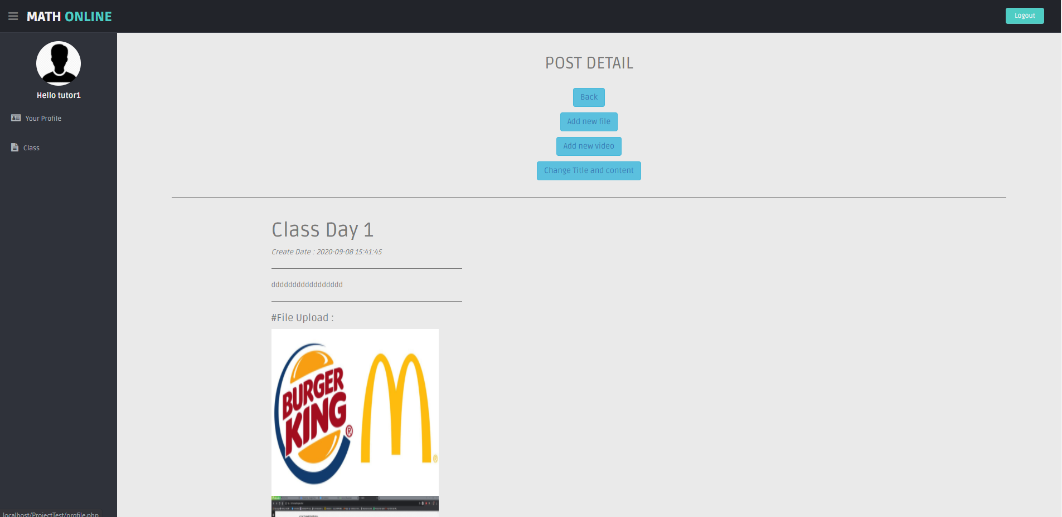

Figure 46: Class detail – teacher

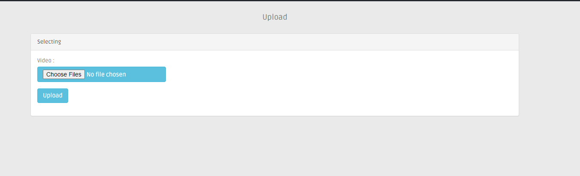

Figure 47: file & video upload

## Profile – teacher

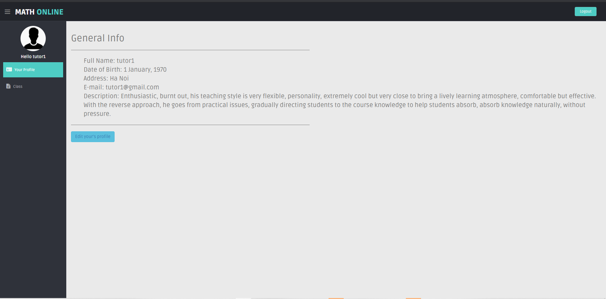

Figure 48: Profile - teacher

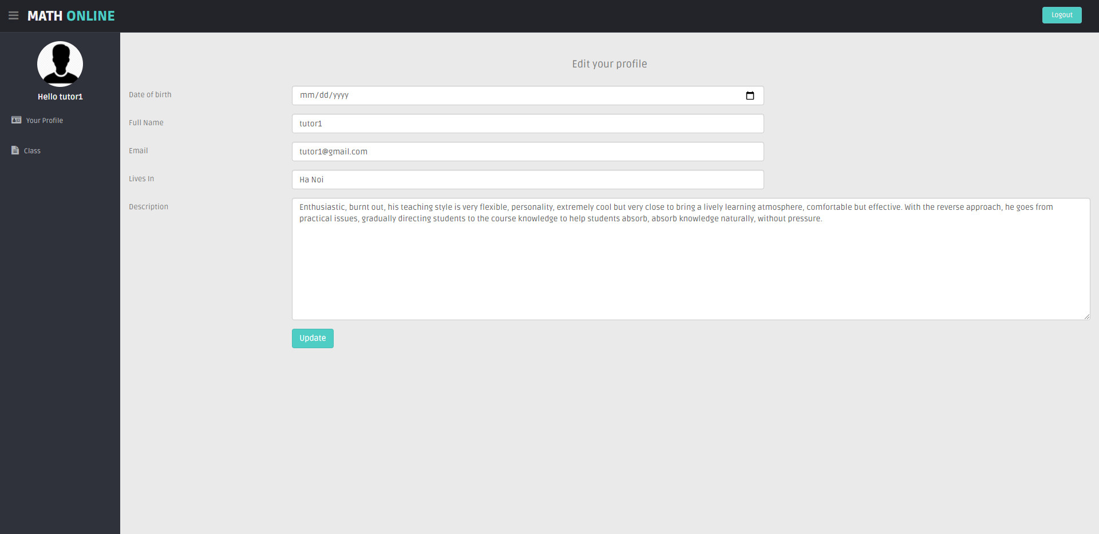

Figure 49: Edit profile – teacher

## Edit role – staff

Staff can view the list of users and edit their roles. This helps the staff to control and partition for teachers. Restricting student registration of teachers confuses the system.

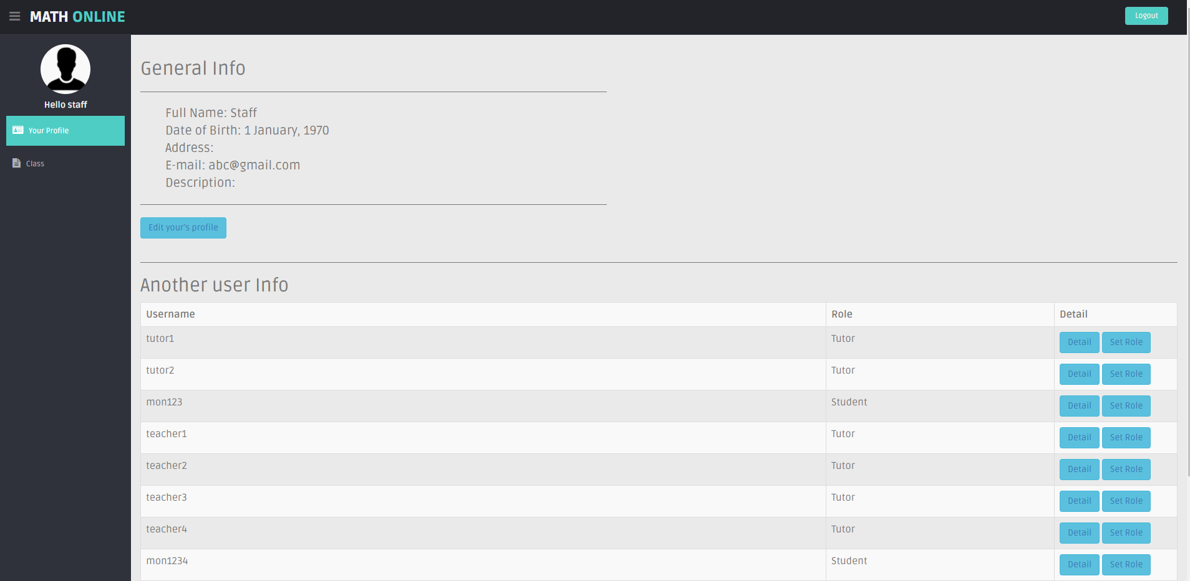

Figure 50: Profile - staff

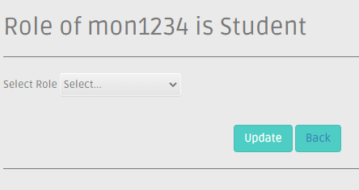

Figure 51: Edit role

# Evaluation

## Human Interaction

The online math learning system is designed based on some typical design principles (Nielsen's 10 heuristics). In this section, I will briefly introduce some system design based on this principle.

### Visibility of system status

The online learning system always gives feedback to users. When the user loads the pages, the system will appear a load animation to help the user know what is happening in the process of using the system. This will greatly increase the user experience.

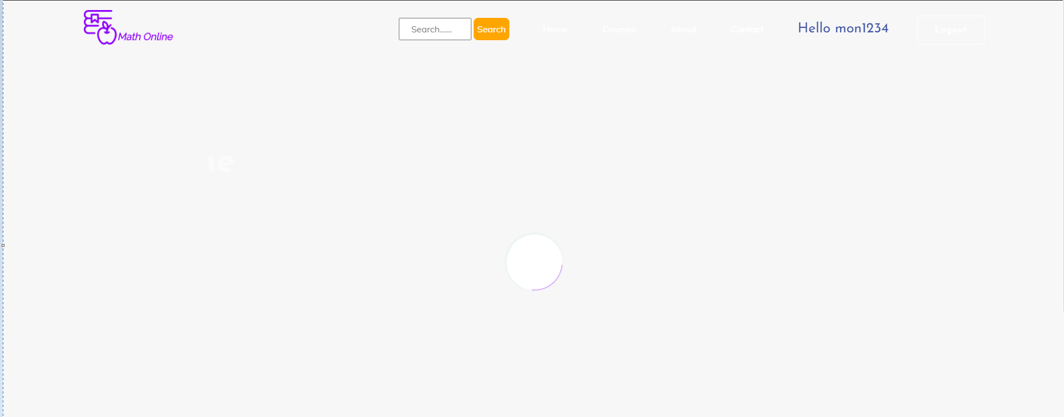

Figure 52: Visibility of system status

### User control and freedom

The website has always provided the navbar on all feature pages. When a user is redirected to a page they do not want, they can use the navbar buttons to navigate the site to their liking. Avoid stuck situations that cause an undesirable user experience with this system.



Figure 53: User control and freedom

### Consistency and standards

The system will use two main colors are purple and white. The main title will always be set to purple. The buttons in the system will be white, when the user points the mouse on the button will turn orange. This helps the user to understand the action as well as not having difficulty using the system.

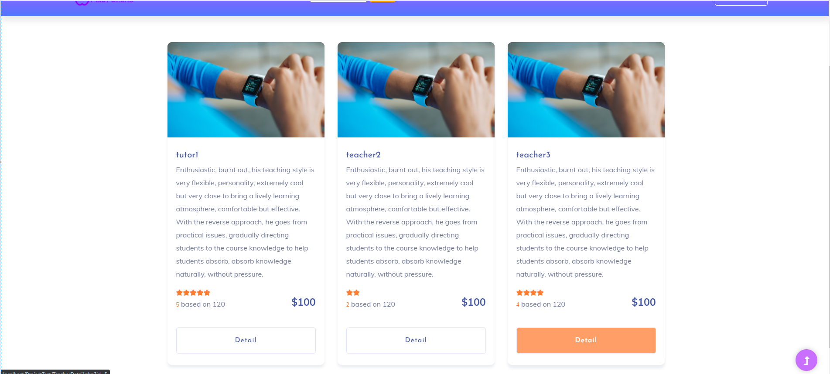Figure 54: Consistency and standards

### Error prevention

Upon registration, users will have warnings that appear to help users understand what to do. If the system does not report an error and the user input it, it will make the user's registration process more complicated. This may prevent users from using the system anymore. Seriously affects the number of users of the system.

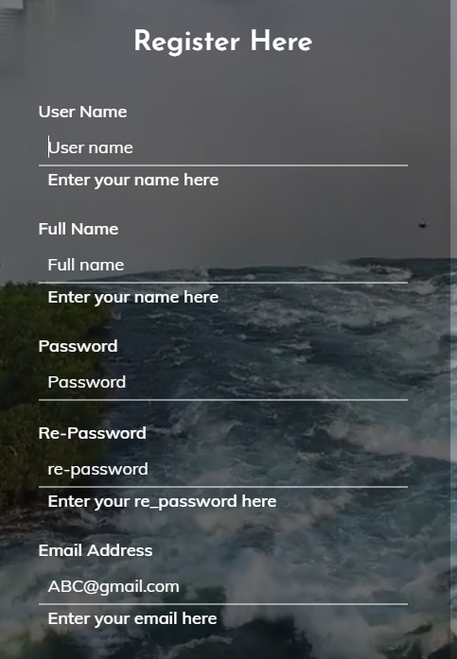

Figure 55: Error prevention

### Aesthetic and minimalist design

My system is designed with minimalism in mind. On the home page, what shows the user is the basic information and the teachers they need. This helps users to have no difficulty getting to know the system and not fall into the situation of not knowing how to use it.

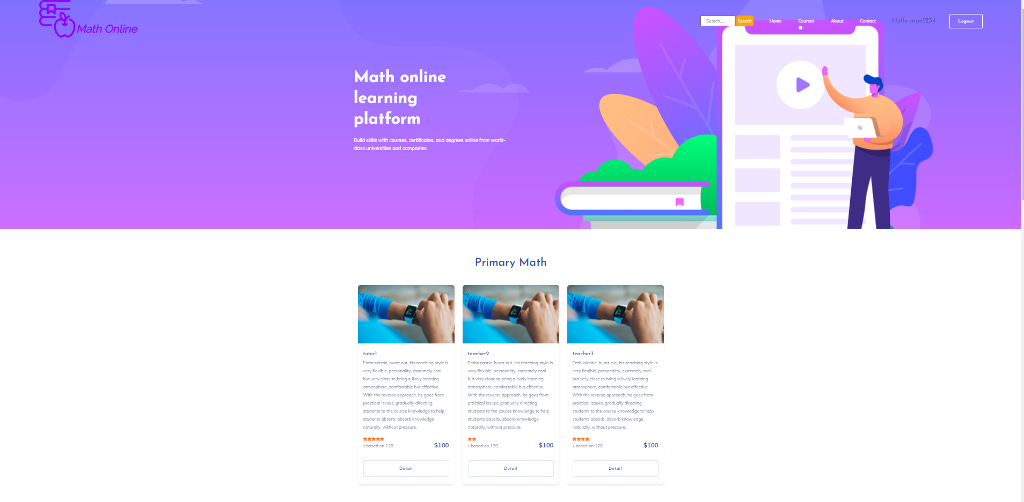

Figure 56: Aesthetic and minimalist design

### Help users recognize, diagnose, and recover from errors

The user will be notified when user enters an incorrect name during login. This will help users know what they did wrong and come up with the best solution.

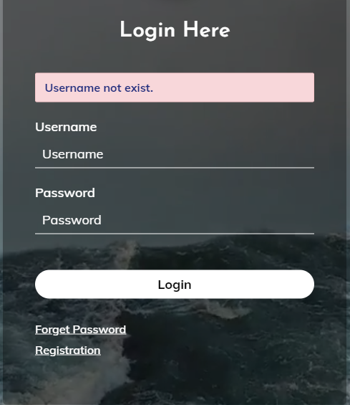

Figure 57: Help users recognize, diagnose, and recover from errors

## Security

The online math learning system is using a number of secure ways. The system has assigned three main permissions for each user, namely staff, teacher and student. When the user is logged in, the system will check the user's permissions and convert them to a page that they are allowed to access. Suppose that, if you are a student, you will not be able to access the site to create classes or control users. When the user is a student, the user will be taken directly to their main school page. Here, the user will be controlled by the system and analyzed the user's data to check their access. If the user is not logged in, they will not be able to view the teachers' classes. For accounts that have not renewed the class, when they click on the classes they will be redirected to the payment method to force the payment before taking the classes. The use of the role system in the online math learning system helps users to use the system in accordance with their role. Avoid misuse cases that cause the system to fail.

In addition, the system needs to use some security methods in the future gas system is put into operation. For example, HTTPS is a protocol used to provide security over the Internet, HTTPS assures users that they are interacting with the expected server and that no one else can block or change the content they are viewing. If there is, anything that users want to be private about, you should only use HTTPS to distribute it. A login form will usually be set up, sent along with any other requests to your page that the user manipulates to log in and is used to validate those requests, hackers will be able to imitate the user perfectly and thereby take over their login session. To deal with these types of attacks, use HTTPS for your entire website. That is no longer as difficult and expensive as it used to be, you just need to turn on HTTPS and have the plus tools available to the frameworks to automatically set this up for you.

## Testing

I will initialize test cases for each function in my system, thereby giving the system test results. I will use black box testing method for the testing part. This is a method of software testing done without knowing the internal structure of the software, the way that the tester checks the system as a black box, with no way of seeing the inside of the software.

* It is also known as data direction test or in / out direction test.
* The tester should build groups of input values ​​that will fulfill all of the functional requirements of the program.
* The testers' approach to the system is to not use any knowledge of the programming structure inside the system, see the system as a complete structure, can not interfere inside.

Black Box Testing is mainly done in Function test and System test. This method is so named because software programs, in the eyes of testers, are like a black box; inside that one cannot see. This method tries to find errors in the following categories:

* Incorrect or missing functionality.
* Interface error.
* Error in data structure or external database access.
* Error behavior or performance.
* Initialization and termination of errors.

### Test case

|  |  |
| --- | --- |
| Test case | T1 |
| Initial condition | Have an account with the account name: Thanh123, password: @ thanh123 |
| Input | Account name: Thanh, password: @thanh123 |
| Expected output | Username not exists |
| Result | PASS |
| Reality output | Username not exists |
| Date | 23/11/2020 |
| Tester | Thanh |

|  |  |
| --- | --- |
| Test case | T2 |
| Initial condition | Have an account with the account name: Thanh123, password: @ thanh123 |
| Input | Account name: Thanh123, password: @thanh12 |
| Expected output | Password error |
| Result | PASS |
| Reality output | Password error |
| Date | 23/11/2020 |
| Tester | Thanh |

|  |  |
| --- | --- |
| Test case | T3 |
| Initial condition | Have an account with the account name: Thanh123, password: @ thanh123 |
| Input | Account name: Thanh123, password: @thanh123 |
| Expected output | Login success |
| Result | PASS |
| Reality output | Login success |
| Date | 23/11/2020 |
| Tester | Thanh |

|  |  |
| --- | --- |
| Test case | T4 |
| Initial condition | Users pay money in the system. |
| Input | Choose a payment method and amount. |
| Expected output | Payment success. |
| Result | PASS |
| Reality output | Payment success. |
| Date | 23/11/2020 |
| Tester | Thanh |

|  |  |
| --- | --- |
| Test case | T5 |
| Initial condition | User renewed learning package. |
| Input | Choose renew. |
| Expected output | Successfully renewed. |
| Result | PASS |
| Reality output | Successfully renewed. |
| Date | 23/11/2020 |
| Tester | Thanh |

|  |  |
| --- | --- |
| Test case | T6 |
| Initial condition | User updated personal information. |
| Input | Enter personal information and click edit |
| Expected output | edit successfully |
| Result | PASS |
| Reality output | edit successfully |
| Date | 23/11/2020 |
| Tester | Thanh |

|  |  |
| --- | --- |
| Test case | T7 |
| Initial condition | User downloads file on class. |
| Input | Convictions on files |
| Expected output | Download successfully. |
| Result | PASS |
| Reality output | Download successfully. |
| Date | 23/11/2020 |
| Tester | Thanh |

|  |  |
| --- | --- |
| Test case | T8 |
| Initial condition | User registered. |
| Input | do not enter all required fields |
| Expected output | Report an error in the fields not entered |
| Result | PASS |
| Reality output | Report an error in the fields not entered |
| Date | 23/11/2020 |
| Tester | Thanh |

|  |  |
| --- | --- |
| Test case | T9 |
| Initial condition | User registered. |
| Input | Fill out the required information in the correct format. |
| Expected output | Create account successfully |
| Result | PASS |
| Reality output | Create account successfully |
| Date | 23/11/2020 |
| Tester | Thanh |

|  |  |
| --- | --- |
| Test case | T10 |
| Initial condition | Add a new class |
| Input | Add a title and class content |
| Expected output | Create success |
| Result | PASS |
| Reality output | Create success |
| Date | 23/11/2020 |
| Tester | Thanh |

|  |  |
| --- | --- |
| Test case | T11 |
| Initial condition | Add video to class |
| Input | Add video heavier than allowed |
| Expected output | Video upload failed |
| Result | PASS |
| Reality output | Video upload failed |
| Date | 23/11/2020 |
| Tester | Thanh |

|  |  |
| --- | --- |
| Test case | T12 |
| Initial condition | Add video to class |
| Input | Add video in incorrect format |
| Expected output | Video upload failed |
| Result | PASS |
| Reality output | Video upload failed |
| Date | 23/11/2020 |
| Tester | Thanh |

|  |  |
| --- | --- |
| Test case | T13 |
| Initial condition | Add video to class |
| Input | upload when not selected video |
| Expected output | Video upload failed |
| Result | PASS |
| Reality output | Video upload failed |
| Date | 23/11/2020 |
| Tester | Thanh |

|  |  |
| --- | --- |
| Test case | T14 |
| Initial condition | Add video to class |
| Input | Add video that meets all requirements Press |
| Expected output | Upload video successfully |
| Result | PASS |
| Reality output | Upload video successfully |
| Date | 23/11/2020 |
| Tester | Thanh |

|  |  |
| --- | --- |
| Test case | T15 |
| Initial condition | Add files to class |
| Input | Add files that are heavier than allowed |
| Expected output | file upload failed |
| Result | PASS |
| Reality output | file upload failed |
| Date | 23/11/2020 |
| Tester | Thanh |

|  |  |
| --- | --- |
| Test case | T16 |
| Initial condition | Add files to class |
| Input | Upload files with incorrect format |
| Expected output | file upload failed |
| Result | PASS |
| Reality output | file upload failed |
| Date | 23/11/2020 |
| Tester | Thanh |

|  |  |
| --- | --- |
| Test case | T17 |
| Initial condition | Add files to class |
| Input | upload when the file is not selected |
| Expected output | file upload failed |
| Result | PASS |
| Reality output | file upload failed |
| Date | 23/11/2020 |
| Tester | Thanh |

|  |  |
| --- | --- |
| Test case | T18 |
| Initial condition | Add files to class |
| Input | Add files that meet the requirements |
| Expected output | Upload file successfully |
| Result | PASS |
| Reality output | Upload file successfully |
| Date | 23/11/2020 |
| Tester | Thanh |

|  |  |
| --- | --- |
| Test case | T19 |
| Initial condition | Add comment to class |
| Input | Add comment to class |
| Expected output | Add successfully |
| Result | PASS |
| Reality output | Add successfully |
| Date | 23/11/2020 |
| Tester | Thanh |

|  |  |
| --- | --- |
| Test case | T20 |
| Initial condition | Delete class |
| Input | Delete class |
| Expected output | Delete successfully |
| Result | PASS |
| Reality output | Delete successfully |
| Date | 23/11/2020 |
| Tester | Thanh |

|  |  |
| --- | --- |
| Test case | T21 |
| Initial condition | Edit role |
| Input | User click the edit role button, select the required role and press enter. |
| Expected output | successfully |
| Result | PASS |
| Reality output | successfully |
| Date | 23/11/2020 |
| Tester | Thanh |

### Evaluate

Through the process of testing the system through 21 test cases. I have collected the results and gave some evaluation after the testing of the system. Through 21 test cases, I successfully tested the basic functions of the system. First, with the register and login functions, users are forced to enter the correct values ​​required. If entered incorrectly, the system will report an error and the user will not be able to complete their process. Next to the payment and renewal function, this function worked well and delivered results that were expected. Users can top up and renew the package successfully. With the teacher's function, the creation of classes and the addition of lesson materials for the class proceeded as expected. Attachments that do not meet the formats will be filtered out and not uploaded to the system. Finally, the role setting function.

Thus, after testing the system, the system is fully functional that I programmed. No function has a backlog error. Thus, the system can be set up and uploaded to the server for operation.

## Product Review

Thus, through testing of the system, it has partly been shown that the system is operating normally. With this system, there are three groups of roles used in the system

**Users (student)**

For general users who are students, who have learning needs. The system is created for the main audience of these users. They can access the system to experience. If they want to study, they will need to create an account for them. This will help the system recognize them when they are logged into the system. To access classes users need to recharge the system and renew their package. Once renewed, users can experience all the teachers they desire. In the classroom, they can view the classroom introduction, learn through the lecture videos as well as make comments so they can interact with the teacher.

**Teachers**

For teachers as users, they will be directed to their own interface. Here teachers can create their classes. In each class, users can create their own title, content as well as video of their lecture. Attached are the exercise files. Teachers can comment on and interact with their students right in the classroom.

**Staff**

Staff can control the role of the user. Staff can adjust the role that helps create teachers for the system.

**Conclusion**

Most of the basic requirements for the online math learning system have been established in the system. However, to help the system become competitive with other systems on the market, it is necessary to add new functions to make the system more useful to users.

## Development methodology review

As the method of system development is water fall that I chose. The development of this system is based on the steps of the waterfall model. This project is developed step by step of the water fall model and with the nature of this method, every step is done and encapsulated in 1 month to implement.

At the first step, analyze the request. This step is tied to my litterature review. I have studied the market, learned about the strengths and weaknesses as well as market trends in online learning. Since then I have analyzed and evaluated this potential market. Next I sat down to analyze the technologies to develop a website from which to choose the technology that would be used to develop my system. Next is to find out what similar products are available. I have researched two main products that stand out in the market. Through what I have collected and analyzed, I have established the requirements to be done to develop my project.

In the second step, this is the design step for my system. At this step, I first created the digram usercase for the system. The requirements that were created in the previous step will be applied to create the best user case for this system. With the user case that was created I analyzed and developed the ERD diagram. This is the necessary diagram that helps develop my SQL system. Next, after having shaped the system with the functions that would be in the system, I used the tools to design the model for the system. The model will be the framework to help me design the interface for my system. Once the designs are in place, we'll move on to the next step in developing this system.

At the implementation of the system, all the designs created in the above step will be brought in to develop the system based on them. Front end, back end and database of the system will be developed in parallel throughout the implementation process. First, the framework for the system will be implemented to include the user's role system. This is the most important step to create a logical foundation for the whole system. Then the functions for teacher and staff will be conducted. Since the core of the system is the class so the function of the teacher is absolutely necessary to perform. Next that interface and back end of functions for students will be implemented. Here all the main functions will be created based on a previously analyzed request. However, due to economic problems, I was unable to cooperate with payment parties to include payment plugins in the system. Therefore, the payment function of the system is self-generated based on existing payment types. Although this problem makes the product created can not be put to use but it also somewhat overcomes this defect.

After implementing the system, I will put the system to test and test. The test cases for this system have been given in the previous section. The system has been tested for functionality and the results have been successful. This means that my system was implemented completely on the requests made before. This test step is important, as it will assess whether a product is complete enough to be brought to market. During the test, I found many flaws in the system that need to be developed in the future of this system.

In the deployment part, we will put the system to test and evaluate the success of the system. Due to the limitations of the subject, I cannot post the system for testing on a server environment. Therefore, I ran the system on a local host and brought the demo product for everyone to comment on. Most people find the products very easy to use because of their simplicity. Thus, it can be said that this system can be marketed and used in the future.

Finally, the system maintenance step. Here, during system analysis and implementation I have allocated separate functions to each other. Therefore, system maintenance is completely easy to maintain. This makes the system highly maintainable in the future.

Thus, I have briefly introduced my project implementation process based on the waterfall model project development.

## Future Work

After research and evaluation, I have completed the product as an online math learning website. However, my system still has many incomplete points that need to be overcome in the future and updated with many new features to help the system compete in the current market. First, it is about the database system that they need to be designed more tightly that the key fields of the tables need to be better linked, this will help the system functions to be implemented. the way it is clear and doesn't cause too much error when using it. Next is the system's interface. The current interface of the system is too simple without suggestion fields, and the classroom interface is too simple and does not support much for students. Therefore, in the future, the system needs to be updated more vividly and more eye-catching to help users experience with the system better. Next is about the functions of the system. Currently, the system possesses a fairly basic set of functions that are not really competitive with other systems. For example: The function of the classroom is too basic, it does not really bring a lot of experience for users in the learning process, the payment system is not really complete due to economic problems, the functions of the kernel. members are not really enough to be able to control the system. So in the future, the system needs some more functions to help the system become more complete. The class will have more functions such as livestream, have tests after each lesson, users can private message with the teacher, this will help users have the best, most useful and closest experience. with traditional learning style. On the teacher's side, the teacher's management system needs to have some other functions such as the livestream system, creating tests for each class, knowing which students have selected and joining the class. learning, from which we can interact and support students in the best way. For employees who need a better user management system, get a monthly sales report of the system. From there, it is possible to analyze and develop the development direction for the system to work better.In addition, the online payment system needs to be more complete, and the plugins of existing payment parties can be added. And finally, security, for the website to be able to publish and market, it is necessary to study more security methods to help protect users' data as well as avoid use process performance cases many security vulnerabilities. Thus, in the future, the system needs to update many more features to be able to compete with other systems on the market.

# Conclution

In the process of making online learning systems on the web includes processes such as research, design and development. I have drawn a lot of valuable lessons for myself after completing the project, specifically three valuable experiences are Knowledge, Development Skills, Report Writing Skills.

**1. Knowledge**

Through an overview of the document research process, I have learned for myself the different software and technologies, what is most suitable for my online learning website project. Next it gave me a wide range of knowledge about methodologies and applied the most suitable method to manage the promotion and system development process.

**2. Development Skills**

When doing a project, through the research process, I have applied for my project a programming language in accordance with the direction that I intend to make that project Php framework and indispensable. is MySQL combined to store data for my online learning website.

And it is impossible not to mention the great help of PhD Truong Cong Doan, who has helped me gain a lot of experience in each day of application implementation, programming skills, ability to refine. code accordingly. And then I got the direction and learned the waterfall model, from which I have applied more models to my project. Since then, my project has become promising and completed well ahead of schedule.

**3.Report Writing Skill**

Thanks to the guidance of PhD Truong Doan, I also have an experience of writing reports in a more scientific and logical way. I already know how to outline an outline, how to structure it thoughtfully, how to find useful scholarly articles for my report. These skills are so precious to me, they help me acquire the skills to step firmly on my future journey with real projects waiting for me.

# References

Domantas, 2019. *hostinger.* [Online]   
Available at: https://www.hostinger.com/tutorials/what-is-html  
[Accessed 14 9 2020].

Griffin, L., 2020. *study.* [Online]   
Available at: https://study.com/academy/lesson/what-is-php-used-for-uses-advantages.html  
[Accessed 14 9 2020].

Hussain, W., 2017. *arpatech.* [Online]   
Available at: https://www.arpatech.com/blog/choose-php-for-developing-website/  
[Accessed 14 9 2020].

Morris, S., 2019. *https://skillcrush.com/blog/css/.* [Online]   
Available at: https://skillcrush.com/blog/css/  
[Accessed 14 9 2020].

Morris, S., 2019. *skillcrush.* [Online]   
Available at: https://skillcrush.com/blog/javascript/  
[Accessed 14 9 2020].

Ouellette, A., 2017. *careerfoundry.* [Online]   
Available at: https://careerfoundry.com/en/blog/web-development/what-is-bootstrap-a-beginners-guide/  
[Accessed 14 9 2020].

Preeti Wadhwani, S. G., 2019. *Global Market Insights.* [Online]   
Available at: https://www.gminsights.com/industry-analysis/elearning-market-size  
[Accessed 9 8 2020].

scrum, 2020. *scrum.* [Online]   
Available at: https://www.scrum.org/resources/what-is-scrum  
[Accessed 14 9 2020].

Seif, G., 2019. *kdnuggets.* [Online]   
Available at: https://www.kdnuggets.com/2019/09/machine-learning-recommender-systems.html  
[Accessed 29 9 2020].

toolsqa, 2020. *toolsqa.* [Online]   
Available at: https://www.toolsqa.com/software-testing/waterfall-model/  
[Accessed 14 9 2020].

# APPENDIX A - SOURCE CODE

Code for math online: https://github.com/ThanhMon99/Project-code-mathonline.git

# APPENDIX B - PROJECT PROPOSAL

FINAL YEAR PROJECT PROPOSAL - COMP1108 - PROJECT

Student: Nguyễn Đoàn Duy Thành - Student ID: GCH17409

APRIL 16, 2020

Table of Contents

1 Overrview **Error! Bookmark not defined.**

2 project Aim **Error! Bookmark not defined.**

3 Objectives **Error! Bookmark not defined.**

3.1 To investigation, collecting basic data **Error! Bookmark not defined.**

3.2 To analysis **Error! Bookmark not defined.**

3.3 To design **Error! Bookmark not defined.**

3.4 To implement **Error! Bookmark not defined.**

3.5 To testing **Error! Bookmark not defined.**

3.6 To evaluations **Error! Bookmark not defined.**

3.7 To conclusions **Error! Bookmark not defined.**

4 Legal, Social, Ethical and Professional **Error! Bookmark not defined.**

4.1 Legal **Error! Bookmark not defined.**

4.2 Social **Error! Bookmark not defined.**

4.3 Ethical **Error! Bookmark not defined.**

4.4 Professional **Error! Bookmark not defined.**

5 Planning **Error! Bookmark not defined.**

1 OVERRVIEW

My project Is about learning math Online. Long term payments have been an important subject for second-level and third-level students, even college students. So you have the idea of learning math online on a website. This site helps teachers and students log in through an existing account.

Teachers can get to the schedule they will teach from which students can search and register according to their aspirations. Teachers will be allocated according to the level of student knowledge as mathematics for Level 3 students or advanced mathematics for undergraduate students. From that time each student's account contains information about their education that will help them search for the most appropriate teachers.

Each month the student will deposit funds into their account in order to be able to participate in the online classes that month. Depending on the package they choose they can participate in classes that have high education and are very interested. In the course of online learning, students and lecturers can upload materials or exercises through the classroom chat channel. Trainers can also create exercises with the time the post is set up to ask students to do. On the homework interface, students can do geometry problems by using toolbars to draw pictures directly on it. After finishing and feel loved and wanted to learn the teacher after class, students can integrate the teacher tenure and receive notifications of daily classes.

To implement this project, I will need to define the project implementation method and the programming language for this project. The first is the method of project implementation. This is a project with a long execution time, so I will use the waterfall method to implement this project. This method will implement the project in separate steps. Once done, one step will be moved to the next step and not return to the previous step. This perfectly fits my plan for this project. Next is the selection of programming languages. I will choose php as the main language for this project. Besides, the interface of the system will be designed in html. This is the common language to design the interface of web systems.

2 PROJECT AIM

The aim of this project is to create an online math learning system on the website environment. Nowadays, there is an increasing demand for more subjects, so this online learning system is conceived through the needs of current students. This system will help students improve their knowledge easily, limiting many difficulties compared to traditional learning.

3 OBJECTIVES

3.1 To investigation, collecting basic data

Activities:

1) Find out about current demand and market.

2) Get opinions from students, teachers about visually impaired people today.

3) Learn about similar available systems.

4) Learn about the technology used in the project.

Deliverables:

1) Clearly detailed documentation of the information gathered.

3.2 To analysis

Activities:

1) Analysis report on Investigation

2) Create user diagram

Deliverables:

1) User Diagram Complete

2) User Diagram Analysis Document

3.3 To design

Activities:

1) Plan ideas, database analysis

2) Delve into the requirements, Use Case to identify the classes

3) Analyzing the actions and outcomes that occur in the system

Deliverables:

1) Entity Relationship Diagram

2) Class diagram

3) Activity Diagram

3.4 To implement

Activities:

1) Select the language to develop software (PHP, HTML, JavaScript)

2) Select an integrated development environment (IDE - NetBeans)

3) Write software – Coding

Deliverables:

1) Documentation of language and software choices for products

2) Products-Websites Learn math online with full features to operate

3.5 To testing

Activities:

1) Create test case

2) Security testing

3) Performance testing

4) Usability testing

5) Compatibility testing

6) Functional Testing

7) Synthesis and analysis

Deliverables:

1) Test case

2) Results after performing the testing process

3) Summary and summary reports

3.6 To evaluations

Activities:

1) Create a list of questions about the system

2) Plan, prepare to interview the user about the software

3) Create a user survey of products

4) Summary, evaluation and analysis of results collected from users

Deliverables:

1) Question list

2) Results collected from interviews and surveys

3) Analysis and evaluation reports

3.7 To conclusions

Activities:

1) Summary of analysis reports in the course of making a project

2) Product analysis, the strengths and weaknesses of the system

3) Overall evaluation of the system

4) Planning for future development

Deliverables:

1) Synthesis report

4 LEGAL, SOCIAL, ETHICAL AND PROFESSIONAL

4.1 Legal

With this system, User creation of an account and login will store the user's personal information. Thereby the use of this information must comply with the regulations on data and personal information protection.

Information provided by the user includes name, address, telephone number, credit or debit card information, email address, date of birth, and IP address. Personal information is collected when a customer registers an account at the system taking classes through the website or when the user communicates with any department such as customer service or technical services. via website, phone, email.

Use only information collected from system access to help users have a good experience with the system, provide services and information appropriate to the user. Also use this information to help develop and improve the system to become more useful and attractive to users.

All actions that use user information with bad intentions regardless of who will be prosecuted and excluded from this system.

4.2 Social

This application is an application that provides a new learning environment for users. The application can link with some social applications such as google, Facebook to share and connect users. Absolutely no exchange of information with third-party applications occurs. All user information, learning history and transactions will be strictly confidential.

4.3 Ethical

There are a number of key ethical issues that I will guarantee in the product of my online math system. First, I make sure my system is completely safe from malicious software or source code. The system will not steal users' important personal data or information. I guarantee users will have all the features according to user level in the online learning system (free users, accounts using level account packages). Finally, I will have methods to explain in detail the terms and instructions for using the system to avoid misleading and direct impact on customers.

4.4 Professional

In the process of implementing and perfecting products, they must meet sufficient professionalism. My product will be based on the plans I have set. Online math learning system created and maintained based on user requirements. Always listen to users to analyze and update the system to meet user needs. All personal information, user transactions will only be used for the purpose of development and operation of my system. I guarantee that I will not use such information for malicious purposes in violation of user rights. And finally, this project will be implemented as planned and the quality of the system will be guaranteed as I set out.

5 PLANNING

